Norfolk Community Primary School – History | Topic: Memory Box – Changes within living memory | Main subject: History | Year 1 Autumn 1

 | Timeline
1910 - past |  | 1960s and 1970s - past | 2013 – 2016 – past | 2018 – past | 2019 - present
Over 100 years ago when toys were very different, and children did not have many toys to play with. |  | The years that Y1 children’s Grandparents were younger and played with toys. | The year the Y1 children were born and then went to nursery. | The year the Y1 children started in school in FS2. | The year the children began learning in Y1.
What I should already know

In the Foundation Stage:

I talked about past and present events.

I know that other children don’t always enjoy the same things.

I know about similarities and differences between themselves and others, and among families, communities and traditions.

Key Vocabulary
Memory | Something remembered from the past.
Memory box | A box to keep special memories and treasures that you would like to keep.
Past | A moment of time that is gone or is now a memory.
Present | Something that is happening now.
Long ago | A time that has already happened in the past.
Baby | A very young child who needs to sleep and drink milk.
Toddler | A young child that is learning to walk and talk.
Adult | A person who is fully grown or developed.
Modern | Using up to date ideas, clothes, toys and technology.
Old | Something that was made or built a long time ago.
Knowledge
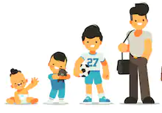
Children grow and change:

Baby
Toddler
Child
Teenager
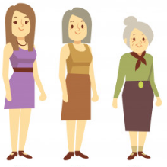
We grow up to be adults and then we grow older.

Adult
Middle adulthood
Old age
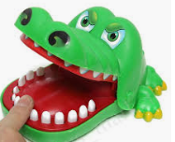
Modern day toys:
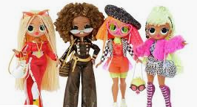
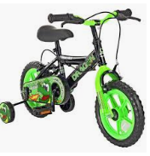
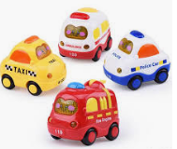
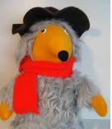
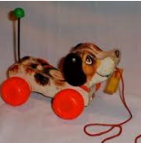
Toys from the past (40 years ago):
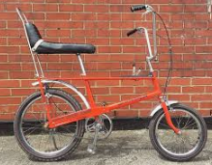
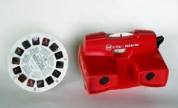

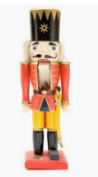
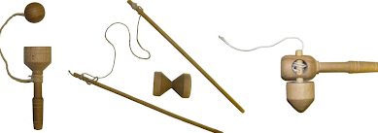
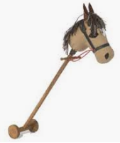
Toys from over 100 years ago:

What I will know by the end of this unit
I will talk about own life and interests and what I like to play with.
I will make a timeline of my own life.
I will recall memories and use photographs from my past to talk about when I was a baby or a toddler.
I will talk about toys I used to play with and clothes I wore when I was a baby.
I will describe similarities and differences between my toys and toys my grandparents used to play with.
I will find out about toys that children played with over 100 years ago.

Useful links
https://www.bbc.co.uk/bitesize/topics/zjnsgk7/resources/1
https://www.everyschool.co.uk/history-key-stage-1-toys.html
https://www.bbc.co.uk/bitesize/clips/z4tmhyc
https://www.bbc.co.uk/bitesize/clips/zt7w2hv



