r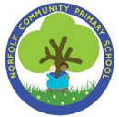unity Primary School
Norfolk Community Primary School
Subject: Art Painting
Year Group: Year 2 Term: Autumn
Overview of unit
● Colour, shape and line linked to mood and the environment
● Link to ‘The Tin Forest’ by Helen Ward
● Create a painting which is half tin forest (cool colours/harsh lines), half plants beginning to grow again (vibrant colours)

Big Ideas – Environment and sustainability
- Understanding how human’s actions impact on the environment and how small things we can do can help to protect our environment
- Recognising that some of the earth’s resources are finite and therefore must be used responsibly by each of us
- Understanding how sustainability is not only about being environmentally friendly but also about thinking about the benefits to the economy and society.
- Engaging and learning about the importance of our natural environment and about the dangers of climate change for future generations
- Appreciating the importance of sustainable resource use – rethink, reduce, repair, re-use, recycle - and obtaining materials from sustainably managed sources
- Explaining the implications of the use of ICT for the environment
- Showing how past actions and choices have had an effect on the environment and so on the quality of people’s lives.
- Teaching the principles of sustainable development and especially fair trade
- Explaining the positive and negative effects of scientific and technological developments on the environment and on people.
- Showing how pupils can become citizens making a contribution to the future well-being of the planet and its people.
- Teaching about beliefs about the created world and how it should be cared for

Concepts – Line, tone and scale

NC objectives (substantive) Y1 and Y2  ● Begin to control lines to create simple drawings from observations  ● Use thick felt tip pens/chalks/charcoal/wax crayon/ pastel  ● Hold a large paint brush correctly  ● Make marks using paint with a variety of tools  ● Consider consistency when applying paint  ● Colour within the line  ● Draw on smaller and larger scales  ● Begin to add detail to line drawings |  |  | Artists  ● Wassily Kandinsky painting  ● Abstract art  Diversity  ● Hilma af Klint
Disciplinary knowledge
What is art? Purpose and meaning |  | What do artists do? |  | What inspires artists
Build on Year 1  • Art can be for a specific purpose, such as designing a building or illustrating a story.  • The purpose of art differs in different cultures. |  | Build on Year 1  • Artists paint representations of the world around them.  • Artists use new and evolving technology to create different ways of making art.  • Artists use traditional and ancient methods of creating art.  • Most artwork is individual and is made by an artist working on their own. Other artwork is collaborative and is made by a group of artists. |  | Build on Year 1  • Art can be for a specific purpose, such as designing a building or illustrating a story.  • The purpose of art differs in different cultures.  • Most artwork is individual and is made by an artist working on their own. Other artwork is collaborative and is made by a group of artists.  • Artists can be inspired by the natural world and have been making art based on the natural world for almost as long as humans have existed.
New Vocabulary  ● Landscape  ● Line  ● Shape  ● Background  ● Primary Colours  ● Secondary Colours  ● Shade (of colour)  ● Mood / Feelings  Emotions | Prior learning  FS2  Create closed shapes with continuous lines and begin to use these shapes to represent objects.  Draw with increasing complexity and detail, such as representing a face with a circle and including details.  Use drawing to represent ideas like movement or loud noises. Show different emotions in their drawings and paintings, like happiness, sadness, fear, etc.  Explore colour and colour mixing.  Year 1 – Painting  ● Hold a large paint brush correctly  ● Recognise and name primary and secondary colours  ● Same what is different and the same about the work of Paul Klee and Anne Estelle Rice.  ● Explain how artists use colour in different ways to represent ideas and meanings.
Crucial Knowledge (To be used for assessment)
To know how colour conveys mood

Mix primary colours to make own secondary colours

Colour within the line

Compare Kandinsky and Hilma of Klint and know what inspired them
Lesson 1  How does Wassily Kandinsky use Landscape  Disciplinary knowledge  Purpose – art from music  Art can be for a specific purpose, such as designing a building or illustrating a story.. | Recap  Recap matching colours to seasons.  Main teaching  - Read ‘The Tin Forest’ by Helen Ward  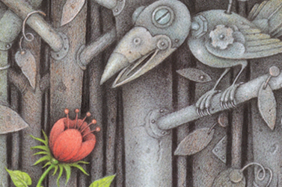  - What happens in the story?  - How did the landscape of the city change?  - How do the changes in colour make you feel?  - Link to environment / pollution etc  - Learn about Wassily Kandinsky  Introducer new Vocabulary - figures, composition and colour.  Group activity  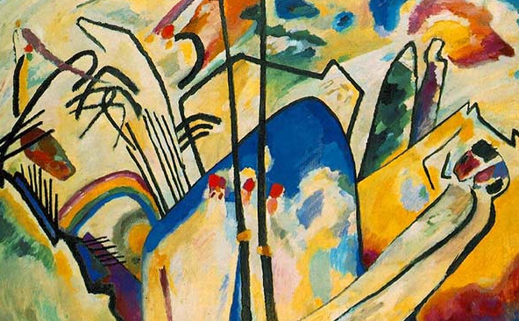  What do you like about his paintings? What do you notice?  Independent Activity  In books  - Stick artwork by Wassily Kandinsky  - Label the picture with shared discussion words e.g. line, shape, colours you can see, facts about the artist
Lesson 2  How does Hilma of Klimt use Primary and secondary colours  Substantive knowledge  Mix primary colours to make own secondary colours)  Disciplinary knowledge  Artist use a variety of methods to create tone and make something that represents something else. | Recap  Recap new Vocabulary - figures, composition and colour.  Introduce primary and secondary colours  Model how to mix primary colours to make own secondary colours  Share colour charts to compare variations of same colour, Look at the colour charts children created.  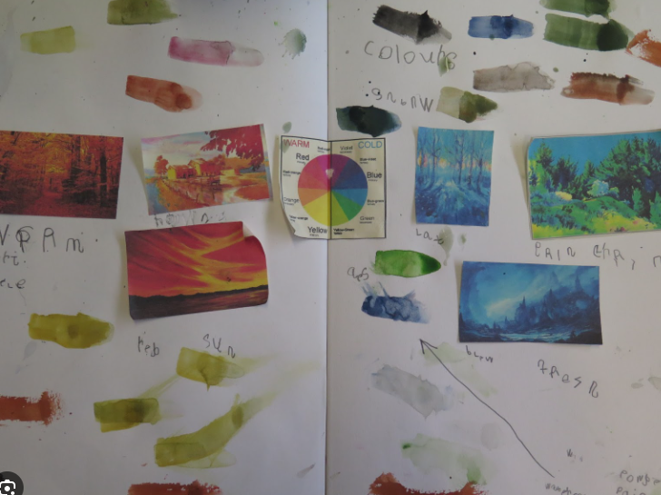  Main teaching  - Recap Wassily Kandinsky  - Introduce work of Hilma af Klimt  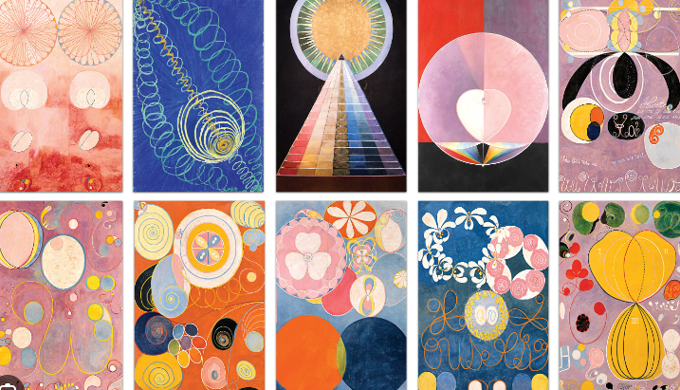  How do the 2 artists compare?  Teacher Model  ● Mix primary colours to make own secondary colours  ● Practise adding varying degrees of white / black to the colours to create different shades.  Independent activity  - Colour mixing page in book  - Make marks with colours made  - Add black / white to colours to create varying shades  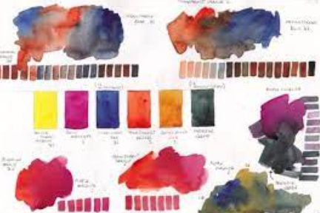
Lesson 3  How do a draw a line  Substantive knowledge  Begin to control lines to create simple drawings from observations  Begin to add detail to line drawings  Disciplinary knowledge  • Most artwork is individual and is made by an artist working on their own. Other artwork is collaborative and is made by a group of artists.  • Artists can be inspired by the natural world and have been making art based on the natural world for almost as long as humans have existed. | Recap  Recap on new vocabulary using frayer model – Colour and composition  Group activity  What is a landscape? TTYP  Look at a variety of landscapes.  Main teaching  Look at work of Wassily Kandinsky and Helen af Klint side by side  Discuss the similarities e.g. use of line, use of colour. What is abstract art? Explain how they both produced abstract art. How could the images in the tin forest be abstract?  Discuss how the use of colour changes. How does the mood change throughout  Group discussion  Show picture of tin forest at the beginning  Pupils to use inspiration from artists to draw tin forest  Independent work  ● Split large piece of paper in half  ● Draw tin forest on one side (to be painted in Week 5)
Lesson 4  How to show mood using colour  Substantive knowledge  Begin to control lines to create simple drawings from observations  Begin to add detail to line drawings  Disciplinary knowledge  • Most artwork is individual and is made by an artist working on their own. Other artwork is collaborative and is made by a group of artists.  • Artists can be inspired by the natural world and have been making art based on the natural world for almost as long as humans have existed. | Recap  Recap on new vocabulary using frayer model – Colour and composition  Match colours to moods  Main teaching  Recap - Look at work of Wassily Kandinsky and Helen af Klint side by side  Discuss the similarities e.g. use of line, use of colour. What is abstract art? Explain how they both produced abstract art. How could the images in the tin forest be abstract?  How do the pictures represent the change that happens?  Discuss how the use of colour changes. How does the mood change throughout  Group discussion  Show picture of forest at the end of the story (more colourful and full of plants)  Independent work  ● Split large piece of paper in half  ● Draw tin forest on one side (to be painted in Week 5)
Lesson 5  How to show mood using colour  Substantive knowledge  Begin to control lines to create simple drawings from observations  Begin to add detail to line drawings  To use contrasting colours  Disciplinary knowledge  • Most artwork is individual and is made by an artist working on their own. Other artwork is collaborative and is made by a group of artists.  • Artists can be inspired by the natural world and have been making art based on the natural world for almost as long as humans have existed. | Recap  Features of a self -portrait recap quiz.  Main teaching  Teacher to model  ● Pupils given primary colours and palettes to paint on their drawings  ● Focus on staying within the lines  ● Focus on contrasting colours between the 2 sides.  Independent work  Use drawings from previous 2 weeks to create a half and half tin forest painting, inspired by Wassily Kandinsky and Helen af Klint  Convergent – Children’s picture will look very similar to Tin forest. They will have drawn similar shapes  Divergent - Children’s picture will use some of the style of Kandinsky and Hilda of Kilnt but will have own style  Plenary  Self-Evaluation  Use these criteria to assess.  I have used colour to convey mood  I have mixed primary colours to make own secondary colours  I have coloured within the line

