Norfolk Community Primary School
Online Safety Policy
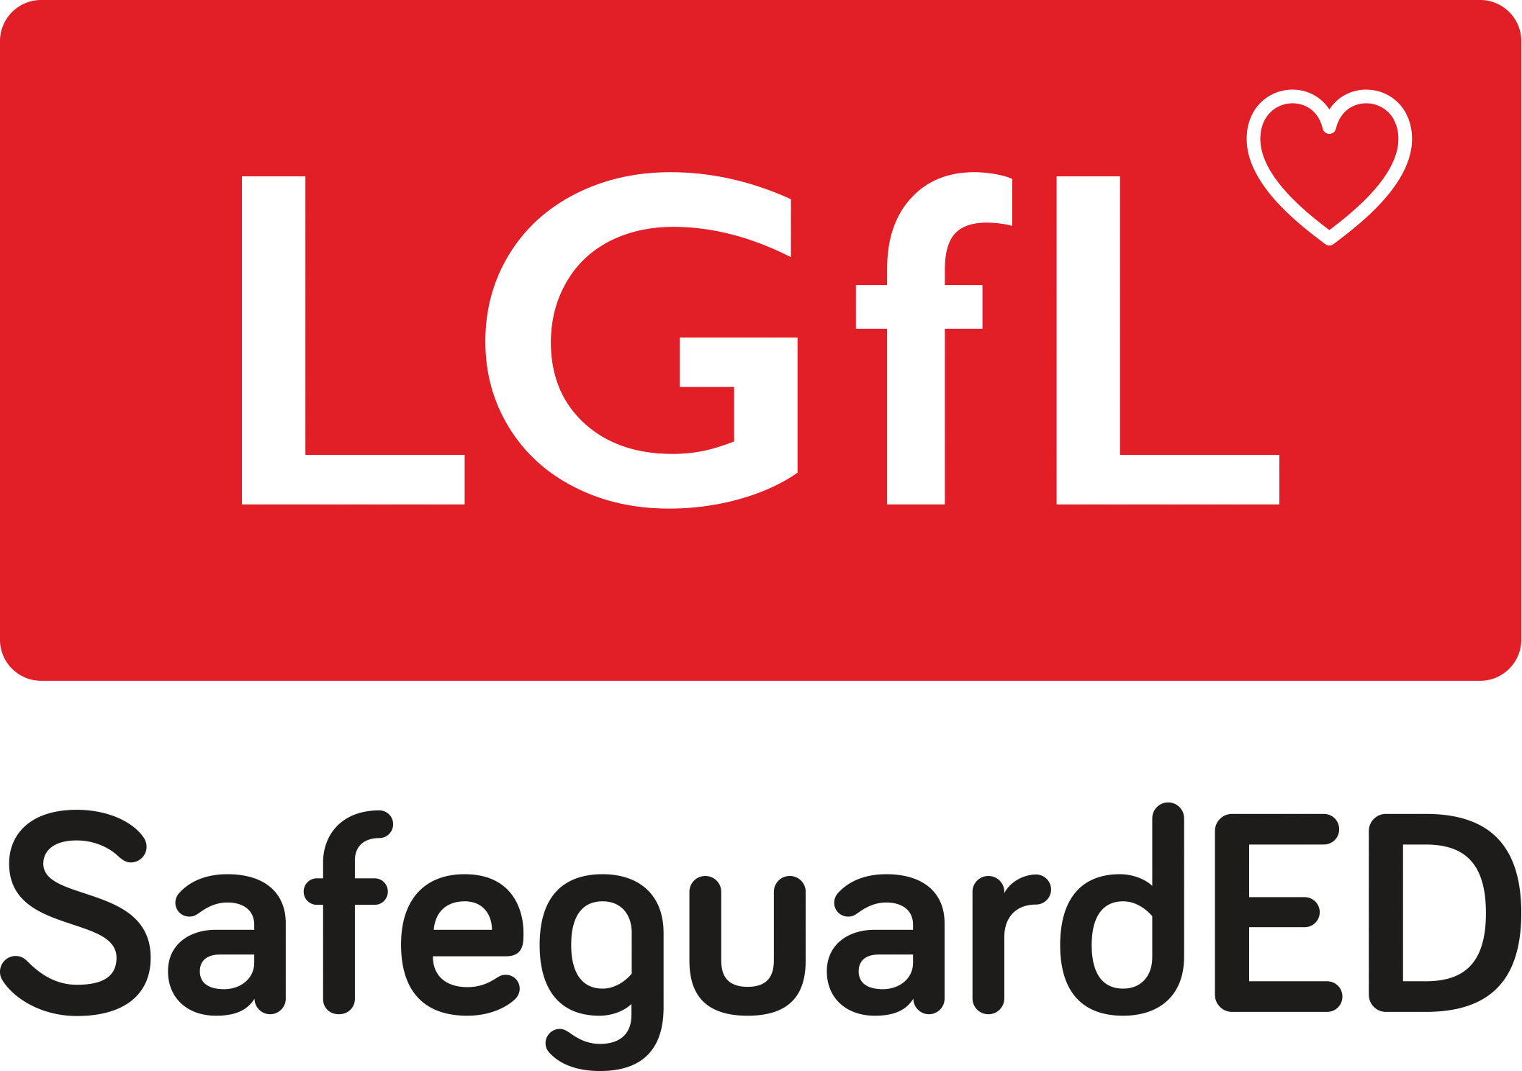


Introduction

Key people / dates
Designated Safeguarding Lead (DSL), with lead responsibility for filtering and monitoring | Cath Whittingham - Head Teacher
Deputy Designated Safeguarding Leads | Rachel Johnson - Assistant Head  Andrea Woodhams - Assistant Head  Eve Goodgrove - SENDCo
Link governor for Safeguarding | Gary Aiston
Link governor for Web Filtering | Gary Aiston
Curriculum Leads with relevance to online safeguarding and their role | Amy Lumsden - RSHE Lead  Sian Golding - Computing Lead
Network manager / other technical support | Ekte
Last reviewed | Spring 2026
Next review due | Spring 2027

What is this policy?
Online safety is an integral part of safeguarding and requires a whole school, cross-curricular approach and collaboration between key school leads. Accordingly, this policy is written in line with ‘Keeping Children Safe in Education’ 2025 (KCSIE), ‘Teaching Online Safety in Schools’, statutory RSHE guidance and other statutory documents. It is cross-curricular (with relevance beyond Relationships, Health and Sex Education, Citizenship and Computing) and designed to sit alongside and be integrated into the school’s statutory Child Protection and Safeguarding Policy. Any issues and concerns with online safety must always follow the school’s safeguarding and child protection procedures.

Who is it for; when is it reviewed?
This policy is a living document, subject to full annual review but also amended where necessary during the year in response to developments in the school and local area. Although many aspects will be informed by legislation and regulations, we will involve staff, governors, pupils and parents in reviewing the policy and making sure the policy makes sense and is possible to follow in all respects. This will help ensure that all stakeholders understand the rules that are in place and why, and that the policy affects day-to-day practice. Pupils could help to design a version in language their peers understand or help to audit compliance. Acceptable Use Policies (see appendices) for different stakeholders help with this - these are reviewed alongside this overarching policy. Any changes to this policy will be immediately disseminated to all the above stakeholders.

Who is in charge of online safety?
KCSIE makes clear that “the designated safeguarding lead should take lead responsibility for safeguarding and child protection (including online safety).” The DSL can delegate activities but not the responsibility for this area and whilst subject leads, e.g. for RSHE will plan the curriculum for their area, it is important that this ties into a whole-school approach.

What are the main online safety risks in 2024/2025?
Current Online Safeguarding Trends
In our school over the past year, we have particularly noticed the following in terms of device use and abuse and types of online/device-based incidents which affect the wellbeing and safeguarding of our :
- Children experiencing abuse or bullying through WhatsApp and Snapchat
- Children watching violent, abusive and disablist characters online who are marketed as engaging to children
- Addiction to online gaming which affects mental health, school engagement and relationships with other peers/adults
Pupil voice was collected through class questionnaires in Spring 2024 which showed:
- Children are accessing a range of games and apps which they are underage to join (GFA, Tiktok and Instagram being some of the main platforms).
- Children have a range of devices which many children report accessing unsupervised from as young as Reception.
- Children have worries about speaking to strangers online and not always knowing who they are playing games with.
Nationally, some of the latest trends of the past twelve months are outlined below. These are reflected in this policy and the acceptable use agreements we use and seen in the context of the 5 Cs (see KCSIE for more details), a whole-school contextual safeguarding approach that incorporates policy and practice for curriculum, safeguarding and technical teams.
- Last year, we highlighted the rapid rise of generative AI (GenAI). Since then, the trend has exploded. Thousands of sites now offer AI-generated content, including disturbing levels of abusive, pornographic and even illegal material like child sexual abuse content. Some platforms host AI ‘girlfriends’, unregulated therapy bots and even chatbots that encourage self-harm or suicide - tools that many students can access freely at home or school. Chatbots can also blur reality, offering harmful advice or engaging in sexualised and bullying conversations. Their addictive design and unmoderated nature heighten the risk of overuse and exploitation.
- When used for generating text, GenAI presents multiple risks. It can spread misinformation, facilitate plagiarism and, most worryingly, bypass safety settings. Many tools lack effective age controls and produce inappropriate content.
- Beyond text, GenAI makes it easier than ever to create sexualised images and deepfake videos. These can have a devastating emotional and physical impact on young people, including blackmail and abuse. The Internet Watch Foundation has warned of a sharp rise in AI-generated child sexual abuse imagery. Alarming reports also show children using nudifying apps to create illegal content of peers.
- We regularly see AI searches involving sexualised and harmful content. It’s critical to stress that in the UK, any CSAM (child sexual abuse material) - AI-generated, photographic or even cartoon - is illegal to create, possess, or share.
- Schools must address this not just in the classroom, but by educating parents and students on safe use at home. For guidance and resources, visit genai.lgfl.net.
- Ofcom’s ‘Children and parents: media use and attitudes report 2025’ has shown that YouTube remains the most used site or app among all under 18s, followed by WhatsApp, TikTok, Snapchat and Instagram. With children aged 8-14 spending an average of 2 hours 59 minutes a day online across smartphone, tablet and computer – with girls spending more time online than boys, four in ten parents continue to report finding it hard to control their child’s screentime. Notably, 52% of 8-11s feel that their parents’ screentime is also too high, underlining the importance of modelling good behaviour.
- Given the 13yrs+ minimum age requirement on most social media platforms, it is notable that over half of 3-12-year olds (55%) were reported using at least one app. Despite age restrictions, four in ten admit to giving a fake age online, exposing them to content inappropriate for their age and increasing their risk of harm, with over a third of parents of all 3-17s saying they would allow their child to have a profile on sites or apps before they had reached the minimum age.
- We have also come across online communications platforms that offer anonymous chat services and connect users with random strangers allowing text and video chats. Most of these are easily accessible to children on devices.
- As a school we recognise that many of our children and young people are on these apps regardless of age limits, which are often misunderstood or ignored. We therefore will remind about best practice while remembering that the reality for most of our students is quite different.
This is striking when you consider that 25% of 3-4 year olds have access to their OWN mobile phone (let alone shared devices), rising to over 90 percent by the end of Primary School, and the vast majority have no safety controls or limitations to prevent harm or access to inappropriate material. At the same time, even 3- to 6-year-olds are being tricked into ‘self-generated’ sexual content (Internet Watch Foundation Annual Report) while considered to be safely using devices in the home and for the first time, there were more 7-10-year-olds visible in child sexual abuse material (CSAM) images than 11-13s.
- Growing numbers of children and young people are using social media and apps, primarily TikTok as their source of news and information, with little attention paid to the facts or veracity of influencers sharing news.
- There have also been significant safeguarding concerns where parents have filmed interactions with staff outside the school gates and posted this on social media, putting children and the wider school community at risk of harm. See nofilming.lgfl.net to find out more.
- Cyber Security is an essential component in safeguarding children and features within KCSIE. Sadly, the education sector remains a clear target for cyber-attacks, with the Cyber Security Breaches Survey 2025 reporting high levels of schools being attacked nationally, with 60% of secondary schools and 44% of primary schools reporting a breach or attack in the past year.

How will this policy be communicated?
This policy can only impact upon practice if it is a (regularly updated) living document. It must be accessible to and understood by all stakeholders. It will be communicated in the following ways:
- Posted on the school website
- Part of the school induction pack for all new staff (including temporary, supply and non-classroom-based staff and those starting mid-year)
- Integral to safeguarding updates and training for all staff (especially in September refreshers)
- Clearly reflected in the Acceptable Use Policies (AUPs) for staff, volunteers, contractors, governors, pupils and parents/carers (which must be in accessible language appropriate to these groups), which will be issued to the whole school community on entry to the school, annually and whenever changed, plus displayed in school

Contents
Introduction 1
Key people / dates 1
What is this policy? 2
Who is it for; when is it reviewed? 2
Who is in charge of online safety? 2
What are the main online safety risks in 2023/2024? 2
How will this policy be communicated? 4
Contents 4
Overview 7
Aims 7
Further Help and Support 7
Scope 8
Roles and responsibilities 8
Education and curriculum 8
Handling safeguarding concerns and incidents 10
Actions where there are concerns about a child 11
Sexting – sharing nudes and semi-nudes 13
Upskirting 14
Bullying 14
Child-on-child sexual violence and sexual harassment 14
Misuse of school technology (devices, systems, networks or platforms) 15
Social media incidents 15
Data protection and cybersecurity 17
Appropriate filtering and monitoring 17
Messaging/commenting systems (incl. email, learning platforms & more) 19
Authorised systems 19
Behaviour / usage principles 20
Online storage or learning platforms 20
School website 21
Digital images and video 21
Social media 22
Our SM presence 23
Staff, pupils’ and parents’ SM presence 23
Device usage 25
Personal devices including wearable technology and bring your own device (BYOD) 25
Use of school devices 26
Trips / events away from school 26
Searching and confiscation 27
Appendix – Roles 28
All staff 28
Headteacher/Principal 28
Designated Safeguarding Lead / Online Safety Lead 30
Governing Body, led by Online Safety / Safeguarding Link Governor 31
PSHE / RSHE Lead/s 32
Computing Lead 33
Subject / aspect leaders 33
Network Manager/other technical support roles 34
Data Protection Officer (DPO) 35
Volunteers and contractors (including tutor) 35
Pupils 36
Parents/carers 36
External groups including parent associations – 36

Overview

Aims
This policy aims to promote a whole school approach to online safety by:
- Setting out expectations for all Norfolk Primary School community members’ online behaviour, attitudes and activities and use of digital technology (including when devices are offline)
- Helping safeguarding and senior leadership teams to have a better understanding and awareness of all elements of online safeguarding through effective collaboration and communication with technical colleagues (e.g. for filtering and monitoring), curriculum leads (e.g. RSHE) and beyond.
- Helping all stakeholders to recognise that online/digital behaviour standards (including social media activity) must be upheld beyond the confines of the school gates and school day, regardless of device or platform, and that the same standards of behaviour apply online and offline.
- Facilitating the safe, responsible, respectful and positive use of technology to support teaching & learning, increase attainment and prepare children and young people for the risks and opportunities of today’s and tomorrow’s digital world, to survive and thrive online
- Helping school staff working with children to understand their roles and responsibilities to work safely and responsibly with technology and the online world:
- for the protection and benefit of the children and young people in their care, and
- for their own protection, minimising misplaced or malicious allegations and to better understand their own standards and practice
- for the benefit of the school, supporting the school ethos, aims and objectives, and protecting the reputation of the school and profession
- Establishing clear structures by which online misdemeanours will be treated, and procedures to follow where there are doubts or concerns (with reference to other school policies such as Behaviour Policy or Anti-Bullying Policy)

Scope
This policy applies to all members of the Norfolk Primary School community (including teaching, supply and support staff, governors, volunteers, contractors, students/pupils, parents/carers, visitors and community users) who have access to our digital technology, networks and systems, whether on-site or remotely, and at any time, or who use technology in their school role.

Roles and responsibilities
This school is a community, and all members have a duty to behave respectfully online and offline, to use technology for teaching and learning and to prepare for life after school, and to immediately report any concerns or inappropriate behaviour, to protect staff, pupils, families and the reputation of the school. We learn together, make honest mistakes together and support each other in a world that is online and offline at the same time.
Depending on their role, all members of the school community should read the relevant section in Annex A of this document that describes individual roles and responsibilities. Please note there is one for All Staff which must be read even by those who have a named role in another section. There are also pupil, governor, etc role descriptions in the annex.
In 2025/2026, it is vital that all members understand their responsibilities and those of others when it comes to filtering and monitoring. All staff have a key role to play in feeding back on potential issues.

Education and curriculum
Despite the risks associated with being online, Norfolk Community Primary School recognises the opportunities and benefits to children. Technology is a fundamental part of adult life and so developing the competencies to understand and use it, are critical to children’s later positive outcomes. The choice to use technology in school will always be driven by pedagogy and inclusion.
It is important that schools establish a carefully sequenced curriculum for online safety that develops competencies (as well as knowledge about risks) and builds on what pupils have already learned and identifies subject content that is appropriate for their stage of development.
As well as teaching about the underpinning knowledge and behaviours that can help pupils navigate the online world safely and confidently regardless of the device, platform or app, Teaching Online Safety in Schools recommends embedding teaching about online safety and harms through a whole school approach and provides an understanding of these risks to help tailor teaching and support to the specific needs of pupils, including vulnerable pupils – dedicated training around this with curriculum mapping for RSHE/PSHE and online safety leads is available at safetraining.lgfl.net
The teaching of online safety features particularly in these areas of curriculum delivery:
- Relationships, Sex and Health Education (RSHE)
- Personal, Social, Health and Economic Education
- Computing
- Citizenship
However, as stated in the role descriptors above, it is the role of all staff to identify opportunities to thread online safety through all school activities, both outside the classroom and within the curriculum, supporting curriculum/stage/subject leads, and making the most of unexpected learning opportunities as they arise (which have a unique value for pupils)
Whenever overseeing the use of technology (devices, the internet, new technology such as augmented reality, etc) in school or setting as homework tasks, all staff should encourage sensible use, monitor what pupils/students are doing and consider potential dangers and the age appropriateness of websites (ask your DSL what appropriate filtering and monitoring policies are in place). “Parents and carers are likely to find it helpful to understand what systems schools use to filter and monitor online use. It will be especially important for parents and carers to be aware of what their children are being asked to do online, including the sites they will be asked to access and be clear who from the school or college (if anyone) their child is going to be interacting with online” (KCSIE 2023).
Equally, all staff should carefully supervise and guide pupils when engaged in learning activities involving online technology (including, extra-curricular, extended school activities if relevant and remote teaching), supporting them with search skills, critical thinking (e.g. disinformation, misinformation and fake news), age appropriate materials and signposting, and legal issues such as copyright and data law. saferesources.lgfl.net has regularly updated theme-based resources, materials and signposting for teachers and parents.
At Norfolk Community Primary School, we recognise that online safety and broader digital resilience must be thread throughout the curriculum and that is why we are working to adopt the cross-curricular framework ‘Education for a Connected World – 2020 edition’ from UKCIS (the UK Council for Internet Safety).
Annual reviews of curriculum plans / schemes of work (including for SEND pupils) are used as an opportunity to follow this framework more closely in its key areas of Self-image and Identity, Online relationships, Online reputation, Online bullying, Managing online information, Health, Wellbeing and lifestyle, Privacy and security, and Copyright and ownership.
This is done within the context of an annual online safety audit, which is a collaborative effort led by the designated deputies, PSHE lead and computing lead.

Handling safeguarding concerns and incidents
It is vital that all staff recognise that online safety is a part of safeguarding (as well as being a curriculum strand of Computing, PSHE/RSHE and Citizenship). General concerns must be handled in the same way as any other safeguarding concern; safeguarding is often referred to as a jigsaw puzzle, so all stakeholders should err on the side of talking to the online-safety lead / designated safeguarding lead to contribute to the overall picture or highlight what might not yet be a problem.
Support staff will often have a unique insight and opportunity to find out about issues first in the playground, corridors, toilets and other communal areas outside the classroom (particularly relating to bullying and sexual harassment and violence).
School procedures for dealing with online safety will be mostly detailed in the following policies (primarily in the first key document):
- Safeguarding and Child Protection Policy
- Relationships and Positive Behaviour Policy
- Anti-Bullying Policy
- Acceptable Use Policies
- Data Protection Policy, agreements and other documentation (e.g. privacy statement and consent forms for data sharing, image use etc)
This school commits to take all reasonable precautions to ensure safeguarding pupils online but recognises that incidents will occur both inside school and outside school (and that those from outside school will continue to impact pupils when they come into school or during extended periods away from school). All members of the school are encouraged to report issues swiftly to allow us to deal with them quickly and sensitively through the school’s escalation processes.
Any suspected online risk or infringement should be reported to the online safety lead / designated safeguarding lead on the same day – when clearly urgent, it will be made by the end of the lesson. The reporting member of staff will ensure that a record is made of the concern on CPOMS - this includes any concerns raised by the filtering and monitoring systems (see section further on in this policy for more information).
Any concern/allegation about staff misuse is always referred directly to the Headteacher, unless the concern is about the Headteacher in which case the complaint is referred to the Chair of Governors and the LADO (Local Authority’s Designated Officer). Staff may also use the NSPCC Whistleblowing Helpline A poster with details of this / other helplines is displayed in the staff room (see posters.lgfl.net and reporting.lgfl.net).
The school will actively seek support from other agencies as needed (i.e. the local authority, LGfL, UK Safer Internet Centre’s Professionals’ Online Safety Helpline (POSH), NCA CEOP, Prevent Officer, Police, IWF and Harmful Sexual Behaviour Support Service). The DfE guidance Behaviour in Schools, advice for headteachers and school staff September 2024 provides advice and related legal duties including support for pupils and powers of staff when responding to incidents – see pages 31-33 for guidance on child on child sexual violence and harassment, behaviour incidents online and mobile phones.
We will inform parents/carers of online-safety incidents involving their children, and the Police where staff or pupils engage in or are subject to behaviour which we consider is particularly concerning or breaks the law.
The school should ensure all online safety reporting procedures are sustainable for any unforeseen periods of closure.
The following sub-sections provide detail on managing particular types of concern.

Nudes – sharing nudes and semi-nudes
The schools refers to the UK Council for Internet Safety (UKCIS) guidance on sexting - now referred to as Sharing nudes and semi-nudes: advice for education settings. There is a one-page overview called Sharing nudes and semi-nudes: how to respond to an incident for all staff (not just classroom-based staff) to read, in recognition of the fact that it is mostly someone other than the designated safeguarding lead (DSL) or online safety lead to first become aware of an incident, and it is vital that the correct steps are taken. Staff other than the DSL must not attempt to view, share or delete the image or ask anyone else to do so, but to go straight to the DSL.
It is important that everyone understands that whilst the sharing of nudes involving children is illegal, students should be encouraged and supported to talk to members of staff if they have made a mistake or had a problem in this area. The UKCIS guidance seeks to avoid unnecessary criminalisation of children.
The school DSL will use the full guidance document, Sharing nudes and semi-nudes – advice for educational settings to decide next steps and whether other agencies need to be involved (see flow chart below from the UKCIS guidance) and next steps regarding liaising with parents and supporting pupils.
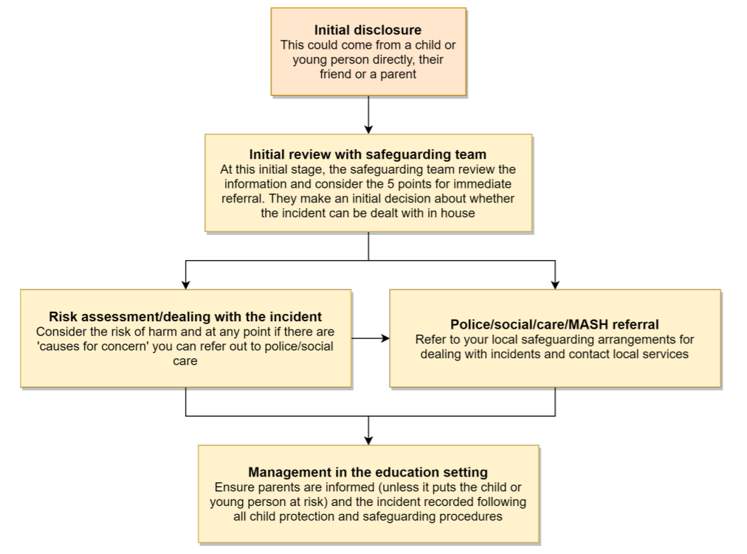
The following LGfL document (available at nudes.lgfl.net) may also be helpful for DSLs in making their decision about whether to refer a concern about sharing of nudes:
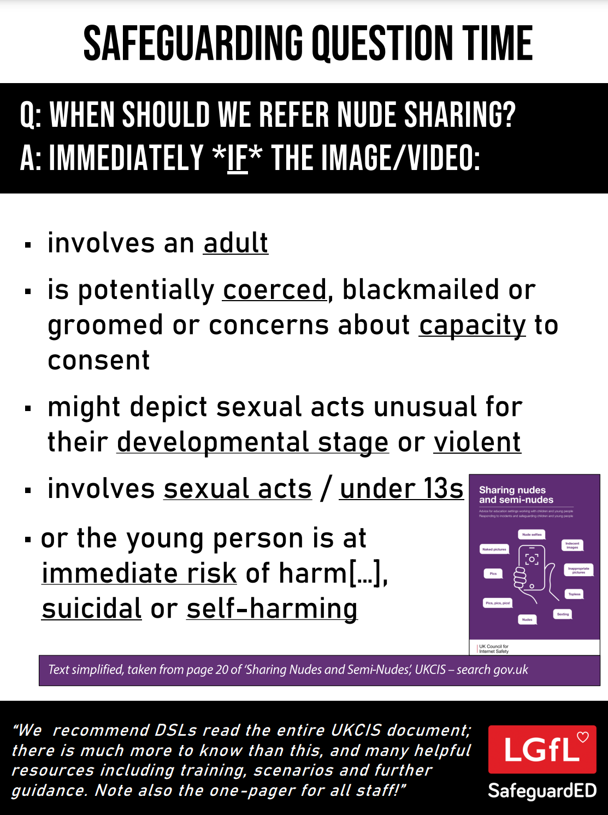

Upskirting
It is important that everyone understands that upskirting (taking a photo of someone under their clothing, not necessarily a skirt) is a criminal offence and constitutes a form of sexual harassment as highlighted in Keeping Children Safe in Education. As with other forms of child-on-child abuse pupils/students can come and talk to members of staff if they have made a mistake or had a problem in this area.

Bullying
Online bullying (which may also be referred to as cyberbullying), including incidents that take place outside of school, will be treated like any other form of bullying and the school Anti-Bullying Policy will be followed. This includes issues arising from banter.
It is important to be aware that sometimes fights are being filmed, live streamed or shared online and fake profiles are used to bully children in the name of others. When considering bullying, staff will be reminded of these issues.
Materials to support teaching about bullying and useful Department for Education guidance and case studies can be found at bullying.lgfl.net

Child-on-child sexual violence and sexual harassment
Any incident of sexual harassment or violence (online or offline) should be reported to the DSL who will follow the guidance in KCSIE. Staff should work to foster a zero-tolerance culture and maintain an attitude of ‘it could happen here’. The guidance stresses that schools must take all forms of sexual violence and harassment seriously, explaining how it exists on a continuum and that behaviours incorrectly viewed as ‘low level’ are treated seriously and not allowed to perpetuate. The document makes specific reference to behaviours such as bra-strap flicking and the careless use of language. This will be discussed in staff training. In the online environment, the recent proliferation of misogynistic content is particularly relevant when it comes to considering reasons for and how to combat this kind of behaviour.

Misuse of school technology (devices, systems, networks or platforms)
Clear and well communicated rules and procedures are essential to govern pupil and adult use of school networks, connections, internet connectivity and devices, cloud platforms and social media (both when on school site and outside of school). These are defined in the relevant Acceptable Use Policy as well as in this document. Where pupils contravene these rules, the school Relationships and Positive Behaviour policy will be applied; where staff contravene these rules, action will be taken as outlined in the staff Code of Conduct. Further to these steps, the school reserves the right to withdraw – temporarily or permanently – any or all access to such technology, or the right to bring devices onto school property.
These rules are reinforced at the beginning of each school year. Pupils will also be reminded that the same applies for any home learning that may take place in future periods of absence/ closure/quarantine etc.
Further to these steps, the school reserves the right to withdraw – temporarily or permanently – any or all access to such technology, or the right to bring devices onto school property.

Social media incidents
See the social media section later in this document for rules and expectations of behaviour for children and adults in the Norfolk School community. These are also governed by school Acceptable Use Policy.
Breaches will be dealt with in line with the school ‘Relationships and Positive Behaviour Policy’ (for pupils) or code of conduct/handbook (for staff).
Further to this, where an incident relates to an inappropriate, upsetting, violent or abusive social media post by a member of the school community, we will request that the post be deleted and will expect this to be actioned promptly.

Where an offending post has been made by a third party, the school may report it to the platform it is hosted on, and may contact the Professionals’ Online Safety Helpline, POSH, (run by the UK Safer Internet Centre) for support or help to accelerate this process.

CCTV
CCTV is used at Norfolk Community Primary School to enhance security. CCTV cameras monitor the external security of the school, which protects the school community’s right to privacy and avoids dignity within the school building. Signage ensures that all members of the school community are aware of the presence of CCTV.

Extremism
The school has obligations relating to radicalisation and all forms of extremism under the Prevent Duty. Staff will not support or promote extremist organisations, messages or individuals, give them a voice or opportunity to visit the school, nor browse, download or send material that is considered offensive or of an extremist nature. We ask for parents’ support in this also, especially relating to social media, where extremism and hate speech can be widespread on certain platforms.

Data protection and cyber security
All pupils, staff, governors, volunteers, contractors and parents are bound by the school’s Data Protection Policy and Cyber Security Policy. It is important to remember that there is a close relationship between both data protection and cyber security and a school’s ability to effectively safeguard children. Schools are reminded of this in KCSIE which also refers to the DfE Standards of Cyber Security for Schools and Colleges.
Schools should remember that data protection does not prevent or limit the sharing of information for the purposes of keeping children safe. As outlined in Data protection in schools, 2023, “It’s not usually necessary to ask for consent to share personal information for the purposes of safeguarding a child.” And in KCSIE 2025, “The Data Protection Act 2018 and UK GDPR do not prevent the sharing of information for the purposes of keeping children safe. Fears about sharing information must not be allowed to stand in the way of the need to safeguard and promote the welfare and protect the safety of children.”

Appropriate filtering and monitoring
The Designated Safeguarding Lead (DSL) [Cath Whittingham,. Headteacher] has lead responsibility for filtering and monitoring and works closely with EKTE to implement the DfE filtering and monitoring standards, which require schools to:
- identify and assign roles and responsibilities to manage filtering and monitoring systems.
- review filtering and monitoring provision at least annually.
- block harmful and inappropriate content without unreasonably impacting teaching and learning.
- have effective monitoring strategies in place that meet their safeguarding needs.
We are committed to providing ‘appropriate filtering and monitoring (as outlined in Keeping Children Safe in Education) at all times.
We ensure that all staff are aware of the filtering and monitoring systems and play their part in feeding back about areas of concern, any potential for students to bypass systems and any potential overblocking.
At Norfolk Community Primary School:
- web filtering is provided by Ekte and iBoss on school site and for school devices used in the home
- changes can be made by the DSL or DSD
- overall responsibility is held by the DSL
- technical support and advice, setup and configuration are from Don Brown at Ekte
- regular checks are made half termly by Rachel Johnson (DSD) to ensure filtering is still active and functioning everywhere. These are evidenced termly.
- an annual review is carried out as part of the online safety audit to ensure a whole school approach.
According to the DfE standards, “a variety of monitoring strategies may be required to minimise safeguarding risks on internet connected devices and may include:
- physically monitoring by staff watching screens of users
- live supervision by staff on a console with device management software network monitoring using log files of internet traffic and web access individual device monitoring through software or third-party services

Messaging/commenting systems (incl. email, learning platforms & more)

Authorised systems
Staff at this school use the email system provided by gmail for all school emails. They never use a personal/private email account (or other messaging platform) to communicate with children or parents/carers, or to colleagues when relating to school/child data, using a non-school-administered system. Staff are permitted to use this email system to communicate with outside professionals, other staff and, on some occasions, parents.
Staff at this school use Class Dojo to communicate with parents and carers.
Any systems above are centrally managed and administered by the school or authorised IT partner (i.e. they can be monitored/audited/viewed centrally; are not private or linked to private accounts). This is for the mutual protection and privacy of all staff, pupils and parents, supporting safeguarding best-practice, protecting children against abuse, staff against potential allegations and in line with UK data protection legislation.
Use of any new platform or app with communication facilities or any child login or storing school/child data must be approved in advance by the school and centrally managed.
Any unauthorised attempt to use a different system may be a safeguarding concern or disciplinary matter and should be notified to the DSL (if by a child) or to the Headteacher (if by a staff member).
Where devices have multiple accounts for the same app, mistakes can happen, such as an email being sent from, or data being uploaded to, the wrong account. If a private account is used for communication or to store data by mistake, the DSL/Headteacher/DPO (the particular circumstances of the incident will determine whose remit this is) should be informed immediately.

Behaviour / usage principles of messaging/commenting systems
More detail for all the points below are given in the Social Media section of this policy as well as in the school’s Acceptable Use Policy, Relationships and Positive Behaviour Policy and Staff Code of Conduct.
Appropriate behaviour is expected at all times, and the system should not be used to send inappropriate materials or language which is, or could be construed as, bullying, aggressive, rude, insulting, illegal or otherwise inappropriate, or which (for staff) might bring the school into disrepute or compromise the professionalism of staff.
Data protection principles will be followed at all times for all school communications, in line with the school Data Protection Policy and only using the authorised systems mentioned above.
Staff are allowed to use the email system for reasonable (not excessive, not during lessons) personal use but should be aware that all use is monitored, their emails may be read and the same rules of appropriate behaviour apply at all times. Emails using inappropriate language, images, malware or to adult sites may be blocked and not arrive at their intended destination (and will be dealt with according to the appropriate policy and procedure).

Use of generative AI
At Norfolk Community Primary School we acknowledge that generative AI platforms (e.g. ChatGPT or Gemini for text creation or the use of Co-Pilot or Adobe Firefly to create images and videos) are becoming widespread. We are aware of and follow the DfE’s guidance on this.
We are aware that there will be use of these apps and exposure to AI creations on devices at home for some children - these experiences may be both positive/creative and also negative (for example, inappropriate data use, misinformation, bullying, deepfakes, nudifying apps and inappropriate chatbots).

In school, we BLOCK the generative AI category on the filtering system: if and when appropriate, gen AI will be allowed on a one-by-one basis for those sites/apps deemed to be acceptable/required.

Areas for development:
- Guidance for staff relating to the use of gen AI to assist with marking, planning and the writing of reports is being considered at Trust level.
- Talking with pupils, staff and parents about the use of these tools – their practical use as well as their ethical pros and cons

Online storage or learning platforms
All the principles outlined above also apply to any system to which you log in online to conduct school business, whether it is to simply store files or data (an online ‘drive’) or collaborate, learn, teach, etc. At Norfolk Community Primary School this includes TEAMS, Zoom and Class Dojo.
For all these, it is important to consider data protection and cyber security before always adopting such a platform or service and when using it. Any new platforms will be approved by the Headteacher, taking into account advice from EKTE.

School website
The school website is a key public-facing information portal for the school community (both existing and prospective stakeholders) with a key reputational value. The Headteacher and Governors have delegated the day-to-day responsibility of updating the content of the website and ensuring compliance with DfE stipulations to the Senior Leadership Team. [LGfL has compiled RAG (red-amber-green) audits at websiterag.lgfl.net to help ensure website requirements are met]
The website is managed by Primary Site
Where staff submit information for the website, they are asked to remember that schools have the same duty as any person or organisation to respect and uphold copyright law – schools have been fined thousands of pounds for copyright breaches. Sources must always be credited, and material only used with permission. There are many open-access libraries of public-domain images/sounds etc that can be used. Finding something on Google or YouTube does not mean that copyright has been respected. If in doubt, check with the DSL.

Digital images and video
When a pupil/student joins the school, parents/carers are asked if they give consent for their child’s image to be captured in photographs or videos, for what purpose (beyond internal assessment, which does not require express consent) and for how long. Parents answer as follows:
- for online prospectus or websites
- for social media (dojo)
- for a specific high-profile image for display or publication
Whenever a photo or video is taken/made, the member of staff taking it will check the latest database before using it for any purpose. Any pupils shown in public facing materials are never identified with more than first name (and photo file names/tags do not include full names to avoid accidentally sharing them).
All staff are governed by their contract of employment and the school’s Acceptable Use Policy, which covers the use of mobile phones/personal equipment for taking pictures of pupils, and where these are stored. At Norfolk Community Primary School no member of staff will ever use their personal phone to capture photos or videos of pupils.
Photos are stored on electronic devices such as IPADS, in line with the retention schedule of the school Data Protection Policy.
Staff and parents are reminded annually and at school events where photographs may be taken about the importance of not sharing images on social media or otherwise without permission, due to reasons of child protection (e.g. children who are looked after by the local authority may have restrictions in place for their own protection), data protection, religious or cultural reasons, or simply for reasons of personal privacy.
We encourage young people to think about their online reputation and digital footprint, so we should be good adult role models by not oversharing (or providing embarrassment in later life – and it is not for us to judge what is embarrassing or not).
Pupils are taught in the online safety education programme about how images can be manipulated and also taught to consider how to publish for a wide range of audiences which might include governors, parents or younger children.
Pupils are advised to be very careful about placing any personal photos on social media. They are taught to understand the need to maintain privacy settings so as not to make personal information public,
Pupils are taught that they should not post images or videos of others without their permission. We teach them about the risks associated with providing information with images, (including the name of the file), that reveals the identity of others and their location. We teach them about the need to keep their data secure and what to do if they / or a friend are subject to bullying or abuse.

Social media

Our SM presence
Norfolk Community Primary School works on the principle that if we don’t manage our social media reputation, someone else will.
Online Reputation Management (ORM) is about understanding and managing our digital footprint (everything that can be seen or read about the school online). Few parents will apply for a school place without first Googling the school, and the Ofsted pre-inspection check includes monitoring what is being said online.
Negative coverage almost always causes some level of disruption. Up to half of all cases dealt with by the Professionals Online Safety Helpline (POSH: helpline@saferinternet.org.uk) involve schools’ (and staff members’) online reputation.
Accordingly, we manage and monitor our social media footprint carefully to know what is being said about the school and to respond to criticism and praise in a fair, responsible manner.

Staff, pupils’ and parents’ SM presence
Social media (including all apps, sites and games that allow sharing and interaction between users) is a fact of modern life, and as a school, we accept that many parents, staff and pupils will use it. However, as stated in the acceptable use policies which all members of the school community sign, we expect everybody to behave in a positive manner, engaging respectfully with the school and each other on social media, in the same way as they would face to face.
This positive behaviour can be summarised as not making any posts which are or could be construed as bullying, aggressive, rude, insulting, illegal or otherwise inappropriate, or which might bring the school or (particularly for staff) teaching profession into disrepute. This applies both to public pages and to private posts, e.g. parent chats, pages or groups.
If parents have a concern about the school, we urge them to contact us directly and in private to resolve the matter. If an issue cannot be resolved in this way, the school Complaints Procedure should be followed. Sharing complaints on social media is unlikely to help resolve the matter, but can cause upset to staff, pupils and parents, also undermining staff morale and the reputation of the school (which is important for the pupils we serve).
Many social media platforms have a minimum age of 13 but the school regularly deals with issues arising on social media involving pupils/students under the age of 13. We ask parents to respect age ratings on social media platforms wherever possible and not encourage or condone underage use.
However, the school has to strike a difficult balance of not encouraging underage use at the same time as needing to acknowledge reality in order to best help our pupils to avoid or cope with issues if they arise. Online safety lessons will look at social media and other online behaviour, how to be a good friend online and how to report bullying, misuse, intimidation or abuse. However, children will often learn most from the models of behaviour they see and experience, which will often be from adults.
Parents can best support this by talking to their children about the apps, sites and games they use (you don’t need to know them – ask your child to explain it to you), with whom, for how long, and when (late at night / in bedrooms is not helpful for a good night’s sleep and productive teaching and learning at school the next day). You may wish to refer to the Digital Family Agreement to help establish shared expectations and the Top Tips for Parents poster along with relevant items and support available from parentonlinesafety.lgfl.net and parentsafe.lgfl.net and introduce the Children’s Commission Digital 5 A Day.
Email and Class Dojo are the official electronic communication channel between parents and the school. Social media, including chat apps such as WhatsApp, are not appropriate for school use.
As outlined in the Acceptable Use Policy, pupils/students are not allowed* to be ‘friends’ with or make a friend request** to any staff, governors, volunteers or contractors, or otherwise communicate via social media.
Pupils/students are discouraged from ‘following’ staff, governor, volunteer or contractor public accounts (e.g. following a staff member with a public Instagram account) as laid out in the AUPs. However, we accept that this can be hard to control (but this highlights the need for staff to remain professional in their private lives). In the reverse situation, however, staff must not follow any public student accounts.
* Exceptions may be made, e.g. for pre-existing family links, but these must be approved by the Headteacher and should be declared upon entry of the pupil or staff member to the school).
** Any attempt to do so may be a safeguarding concern or disciplinary matter and should be notified to the DSL (if by a child) or to the Headteacher (if by a staff member).
Staff are reminded that they are obliged not to bring the school or profession into disrepute and the easiest way to avoid this is to have the strictest privacy settings and avoid inappropriate sharing and oversharing online. They should never discuss the school or its stakeholders on social media and be careful that their personal opinions might not be attributed to the school, trust or local authority, bringing the school into disrepute.
The serious consequences of inappropriate behaviour on social media are underlined by the fact that there has been a considerable number of Prohibition Orders issued by the Teacher Regulation Agency to teaching staff that involved misuse of social media/technology.
All members of the school community are reminded that, particularly in the context of social media, it is important to comply with the school policy on digital images and video and permission must be sought before uploading photographs, videos or any other information about other people. Parents must not covertly film or make recordings of any interactions with pupils or adults in schools or near the school gates, nor share images of other people’s children on social media as there may be cultural or legal reasons why this would be inappropriate or even dangerous (see nofilming.lgfl.net for more information). The school sometimes uses images/video of children for internal purposes such as recording attainment, but it will only do so publicly if parents have given consent on the relevant form.

Device usage
The Acceptable Use Policy (AUP) reminds those with access to school devices about rules on the misuse of school technology – devices used at home should be used as if they were in full view of a teacher or colleague. Please read the following in conjunction with the AUP and the sections of this document which impact upon device usage, e.g. copyright, data protection, social media, misuse of technology, and digital images and video.

Personal devices including wearable technology and bring your own device (BYOD)
Pupils/students in Year5/ Year 6 are allowed to bring mobile phones into school if their parent/carer has given permission for them to do so: they are not allowed to use these during the school day, so pupil phones must be handed in at the start of the day for safe storage in the school office.
Other personal recording devices such as smart glasses are not permitted in school. It is forbidden to take secret photos, videos or recordings of teachers or students, including remotely, with any device.

All staff who work directly with children should leave their mobile phones on silent and only use them in private staff areas during school hours. See also the ‘Digital images and video’ section of this document and the school Data Protection and Cyber Security policies. Child/staff data should never be downloaded onto a private phone. If a staff member is expecting an important personal call when teaching or otherwise on duty, they may leave their phone with the school office to answer on their behalf or ask for the message to be left with the school office. Other personal recording devices such as smart glasses are not permitted in school. It is forbidden to take secret photos, videos or recordings of teachers or students, including remotely, with any device
Volunteers, contractors, governors should leave their phones in their pockets and turned off. Under no circumstances should they be used in the presence of children or to take photographs or videos. If this is required (e.g. for contractors to take photos of equipment or buildings), permission of the Headteacher/ School Business Manager should be sought and this should be done in the presence of a member staff. Other personal recording devices such as smart glasses are not permitted in school. It is forbidden to take secret photos, videos or recordings of teachers or students, including remotely, with any device.
Parents are asked to leave their phones in their pockets and turned off when they are in school. When parents are in the playground for drop-off or collection, use of their phones must not contravene the Online Safety Policy. Parents should ask permission before taking any photos, e.g. of displays in corridors or classrooms, and avoid capturing other children. When at school events, please refer to the Digital images and video section of this document. Parents are asked not to call pupils on their mobile phones during the school day as they will not be accessible; urgent messages can be passed via the school office. We do not allow Apple AirTags or similar devices in school. Please note that it is against the terms and conditions of these products to use them to track a child.
Neither staff nor students are allowed to use a mobile hotspot to provide internet to any device as this would potentially bypass filtering in contravention of the AUP.

Use of school devices
Staff and pupils are expected to follow the terms of the school Acceptable Use Policiy for appropriate use and behaviour when on school devices, whether on site or at home. School devices are not to be used in any way which contravenes the AUP, Relationship and Positive Behaviour Policy or staff Code of Conduct.

Wi-Fi is accessible to professionals visiting the school for school-related internet use / limited personal use within the framework of the acceptable use policy. Staff have been directed not to connect to the wifi on their personal devices unless given permission by the DSL. All such use is monitored.
School devices for staff or students are restricted to the apps/software installed by the school, whether for use at home or school, and may be used for learning and reasonable and appropriate personal use.
All and any usage of devices and/or systems and platforms may be tracked.

Trips / events away from school
For school trips/events away from school, teachers will usually be issued a school duty phone and this number will be used for any authorised or emergency communications with pupils/students and parents. Any deviation from this policy (e.g. by mistake or because the school phone is unavailable/ will not work) will be notified immediately to the Headteacher. Teachers using their personal phone in an emergency will ensure that the number is hidden to avoid a parent or student accessing a teacher’s private phone number.

Searching and confiscation
In line with the DfE guidance ‘Searching, screening and confiscation: advice for schools’, the Headteacher and staff authorised by them have a statutory power to search pupils/property on school premises. This includes the content of mobile phones and other devices, for example as a result of a reasonable suspicion that a device contains illegal or undesirable material, including but not exclusive to sexual images, pornography, violence or bullying.
Full details of the school’s search procedures are available in the school Relationships and Positive Behaviour Policy.

Appendix – Roles
Please read the relevant roles and responsibilities section from the following pages.
All school staff must read the “All Staff” section as well as any other relevant to specialist roles
Roles:
- All Staff
- Headteacher
- Designated Safeguarding Lead
- Governing Body, led by Online Safety / Safeguarding Link Governor
- PSHE / RSHE Lead/s
- Computing Lead
- Subject leaders
- Network Manager/technician
- Data Protection Officer (DPO)
- Volunteers and contractors
- Pupils
- Parents/carers
- External groups including parent associations

All staff
All staff should sign and follow the staff Acceptable Use Policy in conjunction with this policy, the school’s main Safeguarding Policy, the Code of Conduct and relevant parts of Keeping Children Safe in Education to support a whole-school safeguarding approach.
This includes reporting any concerns, no matter how small, to the Designated Safeguarding Lead as named in the AUP, maintaining an awareness of current online safety issues (see the start of this document for issues in 2024/25) and guidance (such as KCSIE), modelling safe, responsible and professional behaviours in their own use of technology at school and beyond and avoiding scaring, victim-blaming language.
Staff should also be aware of the new DfE standards and relevant changes to filtering and monitoring and play their part in feeding back about overblocking, gaps in provision or pupils bypassing protections.

Headteacher – Cath Whittingham
Key responsibilities:
- Foster a culture of safeguarding where online-safety is fully integrated into whole-school safeguarding
- Oversee and support the activities of the designated safeguarding lead team and ensure they work technical colleagues to complete an online safety audit in line with KCSIE (including technology in use in the school).
- Undertake training in offline and online safeguarding, in accordance with statutory guidance and Local Safeguarding Children Partnership support and guidance
- Ensure ALL staff undergo safeguarding training (including online-safety) at induction and with regular updates and that they agree and adhere to policies and procedures
- Ensure ALL governors and trustees undergo safeguarding and child protection training and updates (including online-safety) to provide strategic challenge and oversight into policy and practice and that governors are regularly updated on the nature and effectiveness of the school’s arrangements.
- Ensure the school implements and makes effective use of appropriate ICT systems and services including school-safe filtering and monitoring, protected email systems and that all technology including remote systems are implemented according to child-safety first principles
- Better understand, review and drive the rationale behind decisions in filtering and monitoring as per the new DfE standards—through regular liaison with technical colleagues and the DSL– in particular understand what is blocked or allowed for whom, when, and how as per KCSIE.
- Liaise with the Designated Safeguarding Lead on all online-safety issues which might arise and receive regular updates on school issues and broader policy and practice information
- Support safeguarding leads and technical staff as they review protections for pupils in the home and remote-learning procedures, rules and safeguards
- Take overall responsibility for data management and information security ensuring the school’s provision follows best practice in information handling; work with the DPO, DSL and governors to ensure a compliant framework for storing data, but helping to ensure that child protection is always put first and data-protection processes support careful and legal sharing of information
- Understand and make all staff aware of procedures to be followed in the event of a serious online safeguarding incident
- Ensure suitable risk assessments are undertaken so the curriculum meets needs of pupils, including risk of children being radicalised
- Ensure the school website meets statutory requirements

Designated Safeguarding Lead (DSL) - Cath Whittingham

Online Safety Lead - Rachel Johnson
Key responsibilities
(The DSL can delegate certain online-safety duties but not the overall responsibility; this assertion and all quotes below are from Keeping Children Safe in Education):
- The DSL should “take lead responsibility for safeguarding and child protection (including online safety and understanding the filtering and monitoring systems and processes in place).
- Ensure “An effective whole school approach to online safety as per KCSIE
- In 2023/4 working to take up the new responsibility for filtering and monitoring by working closely with technical colleagues, SLT and the new filtering governor to learn more about this area, better understand, review and drive the rationale behind systems in place and initiate regular checks and annual reviews, including support for devices in the home.
- Where online-safety duties are delegated and in areas of the curriculum where the DSL is not directly responsible but which cover areas of online safety (e.g. RSHE), ensure there is regular review and open communication and that the DSL’s clear overarching responsibility for online safety is not compromised or messaging to pupils confused
- Ensure ALL staff and supply staff undergo safeguarding and child protection training (including online-safety) at induction and that this is regularly updated.
- this must include filtering and monitoring and helping them to understand their roles
- all staff must read KCSIE Part 1 and all those working with children also Annex B – translations are available in 13 community languages at kcsietranslate.lgfl.net (B the condensed Annex A can be provided instead to staff who do not directly work with children if this is better)
- cascade knowledge of risks and opportunities throughout the organisation
- safecpd.lgfl.net has helpful CPD materials including PowerPoints, videos and more
- Ensure that ALL governors and trustees undergo safeguarding and child protection training (including online-safety) at induction to enable them to provide strategic challenge and oversight into policy and practice and that this is regularly updated –[ LGfL’s Safeguarding Training for school governors is free to all governors at safetraining.lgfl.net ]
- Take day-to-day responsibility for safeguarding issues and be aware of the potential for serious child protection concerns
- Be mindful of using appropriate language and terminology around children when managing concerns, including avoiding victim-blaming language [ see spotlight.lgfl.net for a resource to use with staff on how framing things linguistically can have a safeguarding impact, and some expressions we use might be unhelpful ]
- Remind staff of safeguarding considerations as part of a review of remote learning procedures and technology, including that the same principles of online-safety and behaviour apply
- Work closely with SLT, staff and technical colleagues to complete an online safety audit (including technology in use in the school).
- Work with the headteacher, DPO and governors to ensure a compliant framework for storing data, but helping to ensure that child protection is always put first and data-protection processes support careful and legal sharing of information
- Stay up to date with the latest trends in online safeguarding and “undertake Prevent awareness training.” – see safetraining.lgfl.net and prevent.lgfl.net
- Review and update this policy, other online safety documents (e.g. Acceptable Use Policies) and the strategy on which they are based (in harmony with policies for behaviour, safeguarding, Prevent and others) and submit for review to the governors/trustees.
- Receive regular updates in online-safety issues and legislation, be aware of local and school trends – see safeblog.lgfl.net for examples or sign up to the LGfL safeguarding newsletter
- Ensure that online-safety education is embedded across the curriculum in line with the statutory RSHE guidance (e.g. by use of the updated UKCIS framework ‘Education for a Connected World – 2020 edition’) and beyond, in wider school life
- Promote an awareness of and commitment to online-safety throughout the school community, with a strong focus on parents, including hard-to-reach parents – dedicated resources at parentsafe.lgfl.net
- Communicate regularly with SLT and the safeguarding governor/committee to discuss current issues (anonymised), review incident logs and filtering/change control logs and discuss how filtering and monitoring work and have been functioning/helping.
- Ensure all staff are aware of the procedures that need to be followed in the event of an online safety incident, and that these are logged in the same way as any other safeguarding incident.
- Ensure adequate provision for staff to flag issues when not in school and for pupils to disclose issues when off site, especially when in isolation/quarantine, e.g. a survey to facilitate disclosures and an online form on the school home page about ‘something that worrying me’ that gets mailed securely to the DSL inbox
- Ensure staff adopt a zero-tolerance, whole school approach to all forms of child-on-child abuse, and don’t dismiss it as banter (including bullying).

Governing Body, led by Online Safety / Safeguarding Link Governor – Gary Aiston
Key responsibilities (quotes are taken from Keeping Children Safe in Education)
- Approve this policy and strategy and subsequently review its effectiveness, e.g. by asking the questions in the helpful document from the UK Council for Child Internet Safety (UKCIS) Online safety in schools and colleges: Questions from the Governing Board
- Undergo (and signpost all other governors and Trustees to attend) safeguarding and child protection training (including online safety) at induction to provide strategic challenge and into policy and practice, ensuring this is regularly updated
- Ensure that all staff also receive appropriate safeguarding and child protection (including online) training at induction and that this is updated
- Appoint a filtering and monitoring governor to work closely with the DSL on the new filtering and monitoring standards
- Support the school in encouraging parents and the wider community to become engaged in online safety activities
- Have regular strategic reviews with the online-safety coordinator / DSL and incorporate online safety into standing discussions of safeguarding at governor meetings
- Work with the DPO, DSL and headteacher to ensure a compliant framework for storing data, but helping to ensure that child protection is always put first and data-protection processes support careful and legal sharing of information
- Check all school staff have read Part 1 of KCSIE; SLT and all working directly with children have read Annex B
- Ensure that all staff undergo safeguarding and child protection training (including online safety and now also reminders about filtering and monitoring
- Ensure that children are taught about safeguarding, including online safety as part of providing a broad and balanced curriculum.

PSHE / RSHE Lead – Amy Lumsden

Curriculum Lead- Anna Connolly
Key responsibilities:
- As listed in the ‘all staff’ section, plus:
- Embed consent, mental wellbeing, healthy relationships and staying safe online as well as raising awareness of the risks and challenges from recent trends in self-generative artificial intelligence, financial extortion and sharing intimate pictures online into the PSHE / Relationships education, relationships and sex education (RSE) and health education curriculum. “This will include being taught what positive, healthy and respectful online relationships look like, the effects of their online actions on others and knowing how to recognise and display respectful behaviour online. Throughout these subjects, teachers will address online safety and appropriate behaviour in an age appropriate way that is relevant to their pupils’ lives.”
- Work closely with the DSL/OSL and all other staff to ensure an understanding of the issues, approaches and messaging within PSHE / RSHE.
- Note that an RSHE policy should be included on the school website.
- Work closely with the Computing subject leader to avoid overlap but ensure a complementary whole-school approach, and with all other lead staff to embed the same whole-school approach

Computing Lead – Sian Golding
Key responsibilities:
- As listed in the ‘all staff’ section, plus:
- Oversee the delivery of the online safety element of the Computing curriculum in accordance with the national curriculum
- Work closely with the RSHE lead to avoid overlap but ensure a complementary whole-school approach
- Work closely with the DSL/OSL and all other staff to ensure an understanding of the issues, approaches and messaging within Computing
- Collaborate with technical staff and others responsible for ICT use in school to ensure a common and consistent approach, in line with acceptable-use agreements

Subject leaders
Key responsibilities:
- As listed in the ‘all staff’ section, plus:
- Look for opportunities to embed online safety in your subject or aspect, especially as part of the RSHE curriculum, and model positive attitudes and approaches to staff and pupils alike
- Consider how the UKCIS framework Education for a Connected World and Teaching Online Safety in Schools can be applied in your context
- Work closely with the DSL/OSL and all other staff to ensure an understanding of the issues, approaches and messaging within Computing
- Ensure subject specific action plans also have an online-safety element

Network Manager/other technical support roles – Don Brown (EKTE)
Key responsibilities:
- As listed in the ‘all staff’ section, plus:
- Collaborate regularly with the DSL and leadership team to help them make key strategic decisions around the safeguarding elements of technology.
- Note that KCSIE changes expect a great understanding of technology and its role in safeguarding when it comes to filtering and monitoring and in 2023/4 you will be required to support safeguarding teams to understand and manage these systems and carry out regular reviews and annual checks.
- Support DSLs and SLT to carry out an annual online safety audit as now recommended in KCSIE. This should also include a review of technology, including filtering and monitoring systems (what is allowed, blocked and why and how ‘over blocking’ is avoided as per KCSIE) to support their role as per the new DfE standards, protections for pupils in the home and remote-learning.
- Keep up to date with the school’s Online Safety Policy and technical information in order to effectively carry out their online safety role and to inform and update others as relevant
- Work closely with the designated safeguarding lead / online safety lead / data protection officer / LGfL nominated contact / RSHE lead to ensure that school systems and networks reflect school policy and there are no conflicts between educational messages and practice.
- Ensure the above stakeholders understand the consequences of existing services and of any changes to these systems (especially in terms of access to personal and sensitive records / data and to systems such as YouTube mode, web filtering settings, sharing permissions for files on cloud platforms etc
- Maintain up-to-date documentation of the school’s online security and technical procedures
- To report online-safety related issues that come to their attention in line with school policy
- Manage the school’s systems, networks and devices, according to a strict password policy, with systems in place for detection of misuse and malicious attack, with adequate protection, encryption and backup for data, including disaster recovery plans, and auditable access controls.
- Ensure the Data Protection Policy and Cybersecurity Policy are up to date, easy to follow and practicable
- Monitor the use of school technology, online platforms and social media presence and that any misuse/attempted misuse is identified and reported in line with school policy
- Work with the Headteacher to ensure the school website meets statutory DfE requirements.

Data Protection Officer (DPO) – Jordan Widdowson (SSET)

School link: Debra Clarke (SBM)
Key responsibilities:
- Alongside those of other staff, provide data protection expertise and training and support the DP and cybersecurity policy and compliance with those and legislation and ensure that the policies conform with each other and with this policy.
- Not prevent, or limit, the sharing of information for the purposes of keeping children safe. As outlined in Data protection in schools, 2023, “It’s not usually necessary to ask for consent to share personal information for the purposes of safeguarding a child.” And in KCSIE 2023, “The Data Protection Act 2018 and UK GDPR do not prevent the sharing of information for the purposes of keeping children safe. Fears about sharing information must not be allowed to stand in the way of the need to safeguard and promote the welfare and protect the safety of children.”
- Note that retention schedules for safeguarding records may be required to be set as ‘Very long term need (until pupil is aged 25 or older)’. However, some local authorities require record retention until 25 for all pupil records. An example of an LA safeguarding record retention policy can be read at safepolicies.lgfl.net, but you should check the rules in your area.
- Ensure that all access to safeguarding data is limited as appropriate, and also monitored and audited

Volunteers and contractors
Key responsibilities:
- Read, understand, sign and adhere to an Acceptable Use Policy (AUP)
- Report any concerns, no matter how small, to the designated safety lead
- Maintain an awareness of current online safety issues and guidance
- Model safe, responsible and professional behaviours in their own use of technology at school and as part of remote teaching or any online communications
- Note that as per AUP agreement a contractor will never attempt to arrange any meeting, including tutoring session, without the full prior knowledge and approval of the school, and will never do so directly with a pupil. The same applies to any private/direct communication with a pupil.

Pupils
Key responsibilities:
- Read, understand, sign and adhere to the pupil Acceptable Use Policy

Parents/carers
Key responsibilities:
- Read, sign and adhere to the school’s parental Acceptable Use Policy (AUP)
- Read the pupil AUP and encourage their children to follow it

External groups -
Key responsibilities:
- Any external individual/organisation will sign an Acceptable Use Policy prior to using technology or the internet within school
- Support the school in promoting online safety and data protection
- Model safe, responsible, respectful and positive behaviours in their own use of technology, including on social media: not sharing other’s images or details without permission and refraining from posting negative, threatening or violent comments about others, including the school staff, volunteers, governors, contractors, pupils or other parents/carers

