r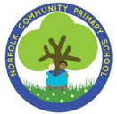unity Primary School
Norfolk Community Primary School
Subject: Art Drawing
Year Group: Year 6 Term: Spring 2
Overview of unit
Develop and understanding of artists work (LS Lowry) and apply it to their own work of an urban landscape. Explore media (pencil, chalks, paint), line, shape and tonal qualities to create perspective

Big Ideas – Identity and Diversity
We will cultivate positive attitudes towards difference and diversity.
Explore the rich cultural diversity of England and Sheffield.
Encourage learners to be confident in their own identity.
Encourage learners to actively engage in exploring a variety of traditions and cultures from around the world.
Explore how differences in gender, culture, class, nationality, religion, ethnicity, language and status may all be significant in shaping identity.
To be able to recognise and challenge stereotypes.
Explore uniqueness and value of every person.
Discover similarities and differences between self and others.
Explore what contributes to self-identity and belonging.
Explore the contributions of different cultures to our lives and where we live.

Concepts –Texture, shape, pattern and composition

NC objectives (substantive)  The national curriculum for art and design aims to ensure that all pupils:  • produce creative work, exploring their ideas and recording their experiences  • become proficient in drawing, painting, sculpture and other art, craft and design techniques  • evaluate and analyse creative works using the language of art, craft and design  • know about great artists, craft makers and designers, and understand the historical and cultural development of their art forms.  To create sketch books to record their observations and use them to review and revisit ideas.  To improve their mastery of art and design techniques including drawing, painting and sculpture with a range of materials (for example, pencil, charcoal, paint, clay)  To learn about great artists, architects and designers in history.  Use first hand observations using different viewpoints, developing more abstract representations  Use a range of mediums on a range of backgrounds  Work indoors and outdoors  Use a variety of techniques to add effects, e.g. shadows, reflection, hatching and cross-hatching and pattern |  |  | Artists  Lowry  Diversity  Friedensreich Hundertwasser
Disciplinary knowledge
What is art? Purpose and meaning |  | What do artists do? |  | What inspires artists
Build on Key stage 1  • Art is ancient. Humans have expressed themselves artistically throughout our existence. |  | Build on key stage 1  • Artists document the world around them, using whatever tools and materials they can create. |  | Build on key stage 1  • Artists can be inspired by the natural world.  • Artists can be inspired by ancient art created by our ancestors.
Build on key stage 1 and Y3  • Sometimes art has hidden messages, or symbols.  • Art can celebrate identity through representation of objects. |  | Build on key stage 1 and Y3  • Artists create compositions based on objects that are meaningful to them.  • Artists include images in their artwork that might have more than one meaning. |  | Build on key stage 1 and Y3  • Artists can be inspired by objects or possessions.  • Artists can be inspired by the materials they are using to create art.
Build on KS1 and LKS2  • Art has been used to tell stories when the majority of people couldn’t read. |  | Build on KS1 and LKS2  • Artists use symbols and images that have meaning to the viewer to tell stories visually. |  | Build on KS1 and LKS2  • Stories from classical mythology, literature and religious texts all inspire artists.  • Artists can be inspired by cultures which are not their own and reinterpret traditional artwork from those cultures to create their work
New Vocabulary  - Pattern  - Tone  - Depth  - Hue  - Shade  - Grayscale  - 3 Dimensional  - Scale | Prior learning  FS2  Create closed shapes with continuous lines and begin to use these shapes to represent objects.  Draw with increasing complexity and detail, such as representing a face with a circle and including details.  Use drawing to represent ideas like movement or loud noises. Show different emotions in their drawings and paintings, like happiness, sadness, fear, etc.  Explore colour and colour mixing.  Year 2 – Drawing  Know that tone can be added to a drawing by shading and filling a shape to make it look three dimensional. (Tone)  Know that different pencil grades make different tones. (Tone)  To add detail to line drawings using shading and tone.  To use scale when drawing features.  Artist use portraits for a variety of reasons.  Year 3 – Drawing  How to create tone and to shade light and dark in drawings  How to create textured surfaces in drawings  How to observe detail and create drawing showing what I see  To recognise how shape is used in drawings  Year 4 – Drawing  Use marks and lines to produce texture.  Organise line, tone, shape and colour to represent figures and forms in movement.  Show reflections. Explain why they have chosen specific materials to draw with.  Further develop drawing a range of tones, lines using a pencil.  Include in their drawing a range of techniques and begin to understand why they best suit
Crucial Knowledge (To be used for assessment)
Use a variety of techniques to add effects, e.g. shadows, reflection, hatching and cross-hatching and pattern
Use sketchbooks to collect and record visual information from different sources as well as planning and colleting source material for future works.
Further develop drawing a range of tones, lines using a pencil.
Use marks and lines and patterns to produce texture.
Understand how to use space in a landscape and include fore/back and middle ground and investigate proportions.
Include a range of techniques and begin to understand why they best suit.
Use first hand observations using different viewpoints, developing more abstract representations

Lesson 1  What can landscapes tell us about identity?  Substantive  To understand how to use composition and line in a landscape.  Disciplinary knowledge  Understand that art can celebrate identity through representation of objects. | Recap  Recap on Y5 vocabulary. Match Textures, Tone, line and scale to their definitions.  What foreground, background and midground?  Main teaching  Start by linking art to Identity and diversity. Explain that art is used to express feelings and identity.  TTYP - Why do artists draw landscapes and places?  Discuss that art is away of expressing identity and culture. Throughout this block we are going to look at drawings of landscapes and how artists express identity through drawing the places in which they live. We will explore how you can learn about a place from a landscape.  Today we are going to look at the importance of landscapes and buildings.  The Superpower of Looking: a block of flats as art | Art UK  TTYP - What can landscapes tell us about identity?  Art theme: landscapes  The term 'landscape' is broad and encompasses seascapes, cityscapes and townscapes too. Historically, landscape painting has been associated with scenes of the natural world. Sometimes the landscape depicted contains no figures or shows human activity as secondary to the environment.  David Hepher's Arrangement in Turquoise and Cream, painted between 1979 and 1981.  The artist describes himself as a landscape painter although we could describe this as an urban cityscape. David Hepher is interested in depicting relatable housing in a modern and documentary style. He describes blocks like these as impressive – everyday local housing interests him in the same way as grand country houses interested artists of the past. Does the artist indicate their architectural worthiness in the way the building fills the composition?  The word 'arrangement' in the title seems to indicate an emphasis on composition. The flats look very modular and the repetition of geometric shapes makes them appear quite rhythmic and homogeneous. Does this regularity affect our view of the lives of the people who live here?  Explore the painting - David Hepher's Arrangement in Turquoise and Cream, painted between 1979 and 1981.  Group activity  Encourage your students to look carefully – this is their superpower! It’s best to not give too much background information about the artwork at this stage, so students can develop their own ideas and opinions.  Now when looking at the painting, ask more specific ('nudge') questions:  - What medium is this artwork? Is it a photograph or a painting?  - How many separate buildings are there? What type of buildings are they?  - If you were transported into this scene, where might you be standing to have this specific viewpoint?  - Is this painting more about the architecture or the people who live within it? Do we need to see people for a work to be about people?  Independent activity  Now we can start to explore the 'elements' of the painting. Use The Superpower of Looking Kit to ask questions about the artwork. For this artwork, you will focus on composition and line  Prompt questions  Composition  - How has the artist chosen to fill the space?  - Can you see any shapes in the painting? Are these shapes repeated?  - Has this scene been cropped?  - What does this tell us about what the artist finds important?  Line  - Do we notice outlines in the painting?  - What do these outlines tell us? Do we expect to see these in real life?  - Can you see diagonal lines? Horizontal and vertical lines?  - What effect does this have?  Plenary  Link the picture to buildings in Sheffield particularly parkhill flats. Explore variety of landscape drawings of parkhill flats.
Lesson 2  What is a landscape?  Substantive knowledge  Introduce fore/back and middle ground Investigate proportions  Disciplinary Knowledge  Understand that art can celebrate identity through representation of objects. | Recap  Show a variety of portraits, landscapes and still life drawings. Children have studied each of these types of drawings. Children to match them to the words. Discuss the difference between each and how we know. Discuss how the different drawing techniques that we have learn in other  Main Teaching  Look at a variety of landscapes – Georges Seurat and Peter Paul Rubens.  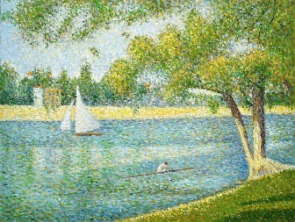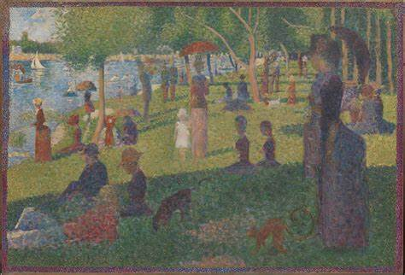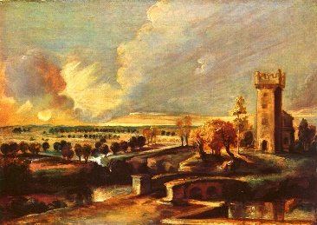  Explore what a landscape is. Introduce the vocabulary Background, Foreground, middleground, Horizon.  These things are very important for making drawings of landscapes look like they are 3D.  What is landscape painting? | KS2 Art and Design | Primary - BBC Bitesize  Independent activity  Children to stick in paintings and annotate by identifying Background, Foreground, middleground, Horizon.  Explain that by the end of this unit they are going to create a landscape drawing of an area of Brazil. They will doing their drawing in the style of an artist that we will be learning about tomorrow but first we need to identify the compositions and arrangement of elements in the drawing first.  Group activity  Look at a variety photos of Brazil (with really clear foreground, back ground and middle ground)and annotate the foreground, background and middle. (see possible examples) Annotate in groups.  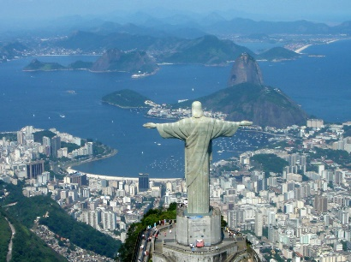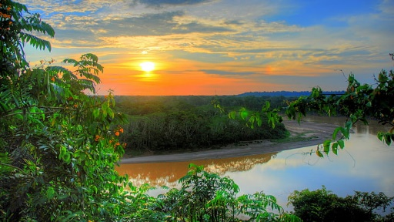  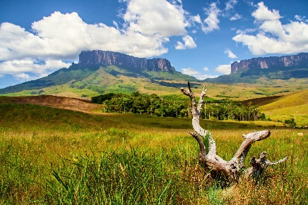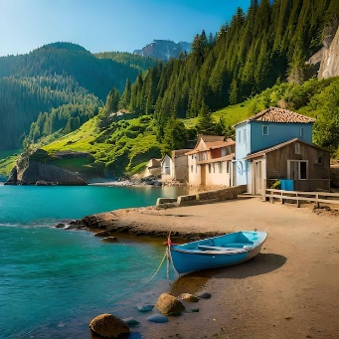  Independent activity  Children to choose their favourite image and a draw the position of the different part of the pictures in their sketch books.
Lesson 3  How do artists make their pictures look realistic?  Substantive knowledge  Use a variety of techniques to add effects, e.g. shadows, reflection, hatching and cross-hatching and pattern  Disciplinary knowledge  Understand that artists use first hand observations using different viewpoints, developing more abstract representations | Recap  How do artists make their drawings look so realistic? Discuss the elements tone and textures.  TTYP - What is tone?  How do we create tone in drawings?  How do we create dark and light areas?  Discuss shading and creating tone with different pencils.  We are going to look at some drawings of landscapes and explore how the artists has made them  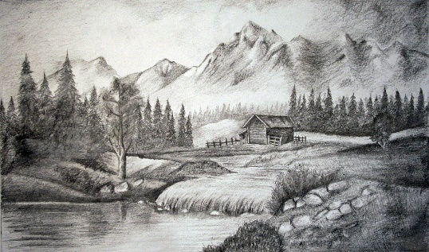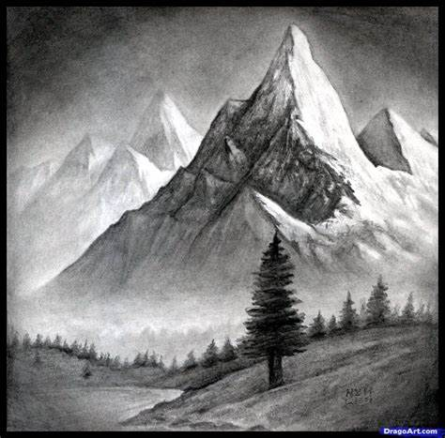  Group Activity  How do you make it look realistic?  How have they created dark and light areas?  Can you see any shadow?  How do they create texture?  How could the artist have used a rubber?  Independent activity  Practice textures patterns in your sketch book  Final activity  Show variety of landscape drawings and painting including a selection of abstract landscapes. Ask children to sort the pictures anyway they want.  Groups to explain how they have sorted the pictures. Then show them split into realistic and abstract. Ask children to a explain why they think the two groups are different.  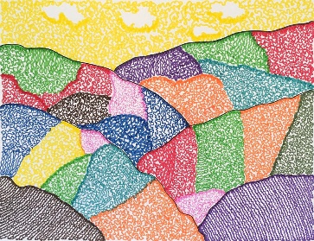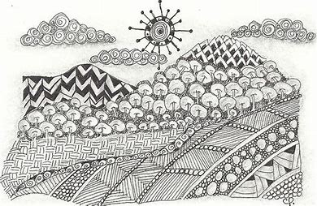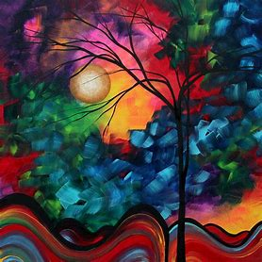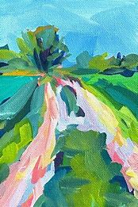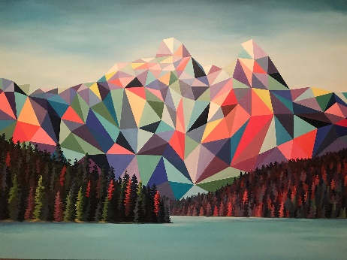  Introduce the word abstract – frayer model
Lesson 4  How do I create an abstract landscape?  Substantive knowledge  Use a variety of techniques to add effects, e.g. shadows, reflection, hatching and cross-hatching and pattern  Include in their drawing a range of techniques and begin to understand why they best suit  Disciplinary knowledge  Understand that artists use first hand observations using different viewpoints, developing more abstract representations | Recap  Recap on new vocabulary using frayer model – Abstract  - Practice drawing texture activity.  Starter  Create a basic landscape shape image using the galapagos image provided  Main teaching  Explain that over the next few weeks they are going to create an abstract landscape of the galapagos using the images we created a few weeks ago. We are going to use the techniques that they have been learning about and we are going to look at another artist to help inspire our work.  Introduce Friedensreich Hundertwasser.  Share facts with children. Who was he and what kind of art did he create.  Group Activity  Provide tables with one of his pictures and children to annotate in groups using the following questions to prompt.  What drawing techniques has he used?  How does he use colour to create emotion?  How does he create light and dark?  How does he create texture?  What does the picture represent?  How does he use patterns to represent places and textures.  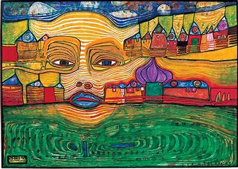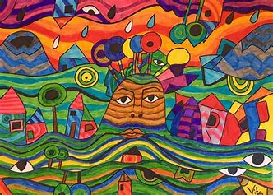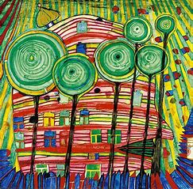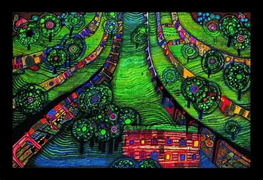  Introduce Zentangle pictures  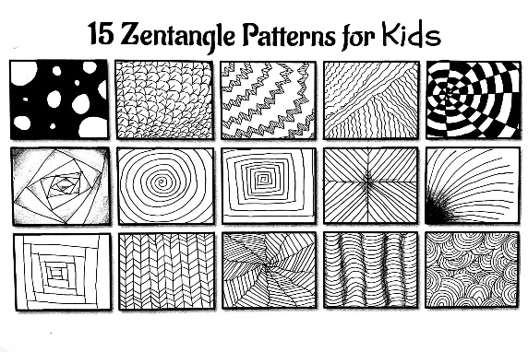  Explain how Zentangle uses patterns to fill spaces in pictures. A Zentangle is a miniature abstract work of art created by a collection of patterns.  It is typically done on a square piece of paper using a pencil and a black pen. The small size allows for a work of art that can be completed in a relatively short period of time.  You have undoubtedly seen this patterning art form before, it has become incredibly popular. “ZEN” means calm and “TANGLE” means a collection of overlapping patterns. ZENTANGLE is the bringing together of the calm and the pattern.  The “zen” part of it is that it can be a very relaxing and meditative experience  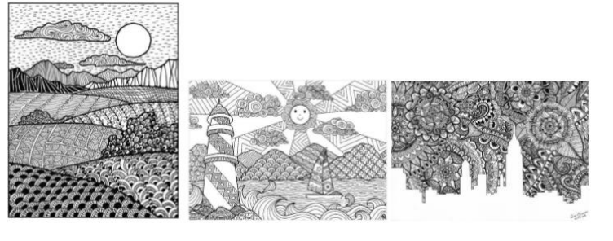Teacher to model how to use zentangle patterns to create landscape. Encourage children to think about choosing the best patterns for different textures. Children also think about how to use pattern to create tone.  Independent task  Children to use their landscape composition to begin to fill the space with patterns using tips
Lesson 5  How can I add detail to our Landscapes?  Assessment criteria  I can use marks and lines and patterns to produce texture.  I can understand how to use space in a landscape and include fore/back and middle ground and investigate proportions.  I can include a range of techniques and begin to understand why they best suit.  I can use first hand observations using different viewpoints, developing more abstract representations  I can use a variety of techniques to add effects, e.g. shadows, reflection, hatching and cross-hatching and pattern | Recap  TTYP – How do artists add detail to their pictures? Shading, texture techniques and tone.  Match definitions.  Main Teaching  Teacher to model using patterns to more detail to their landscape. How do they create dark and light area using different types of patterns and shading.  Independent work  Children to continue with their landscapes  Convergent – Children’s picture will be very similar to one of the images seen.  Divergent - Children’s picture will include original patterns  Plenary  Self-Evaluation  Use these criteria to assess.  I can use marks and lines and patterns to produce texture.  I can understand how to use space in a landscape and include fore/back and middle ground and investigate proportions.  I can include a range of techniques and begin to understand why they best suit.  I can use first hand observations using different viewpoints, developing more abstract representations  I can use a variety of techniques to add effects, e.g. shadows, reflection, hatching and cross-hatching and pattern

