


Norfolk Community Primary School
Attendance Policy

Approved by: | Sheffield South East Trust | Date: July 25
Last reviewed on: | July 2025
Next review due by: | July 2026

Contents
1. Aims 2
2. Legislation and guidance 2
3. Roles and responsibilities 3
4. Recording attendance 4
5. Authorised and unauthorised absence 7
6. Promoting attendance 9
7. Supporting pupils who are absent or returning to school 10
9. Policy monitoring arrangements 11
10. Links with other policies 12
Appendix 1: attendance codes 12
Appendix 2: Inclusive Attendance………………………………………………………………… 15

1. Aims
We know that good attendance at school is important because when they attend regularly and on time, children:
- make better progress, both socially and academically.
- find school routines, learning and friendships easier to cope with.
- find learning more enjoyable.
- are more successful when moving to the next stage in education and in later life employment or training.
- are ready to learn and access all opportunities in school.

We are committed to encouraging every child to have good attendance and punctuality so they can fully access all our schools have to offer and to prepare them for the next stage in their education and life by:
- Promoting good attendance and punctuality
- Reducing absence, including persistent and severe absence
- Ensuring every pupil has access to the full-time education to which they are entitled.
- Acting early to address patterns of absence.
- Building strong relationships with families to ensure pupils have the support in place to attend school.

2. Legislation and guidance
This policy meets the requirements of working together to improve school attendance from the Department for Education (DfE) and refers to the DfE’s statutory guidance on school attendance parental responsibility measures. These documents are drawn from the following legislation setting out the legal powers and duties that govern school attendance:
- Part 6 of The Education Act 1996
- Part 3 of The Education Act 2002
- Part 7 of The Education and Inspections Act 2006
- The Education (Pupil Registration) (England) Regulations 2006 (and 2010, 2011, 2013, 2016 amendments)
- The Education (Penalty Notices) (England) (Amendment) Regulations 2013
It also refers to:
- Keeping Children Safe in Education
- Mental health issues affecting a pupil's attendance: guidance for schools
This policy also complies with our trust’s funding agreement and articles of association.

3. Roles and responsibilities
We believe attendance is everyone’s responsibility, and that everyone has a role to play.
Patrick Wallace is our governor for attendance who promotes the importance of attendance, scrutinises data and ensures this policy is implemented.
Rachel Johnson is our attendance champion and member of the senior leadership team, who works closely with the attendance governor. They lead attendance across the school with a clear vision for attendance improvement that includes an oversight of data analysis and the development and implementation of specific strategies to address poor attendance identified through data.
Mandy Scott-Hopkins is our Attendance and Family Liaison Officer and is responsible for contacting parent/ carers of children who are absent from school without reason.

Sheffield South East Trust has appointed an attendance lead who acts as a central contact for schools with attendance queries and works with individual schools who require support with attendance improvement.
The Trust Attendance Lead also monitors attendance in individual schools and across the trust using data to track trends and inform practice.
The trust attendance lead is Rebecca Sutton and can be contacted on,
 0114 244 1512  07944 339245  r.sutton@sset.education

3.1 Parents/carers
Where this policy refers to a parent, it refers to the adult the school and/or local authority decides is most appropriate to work with, including:
- All natural parents, whether they are married or not
- All those who have parental responsibility for a child or young person
- Those who have day-to-day responsibility for the child (i.e. lives with and looks after them)
Parents/carers are expected to:
- Make sure their child attends every day on time.
- Telephone the school to report their child’s absence before 9am on the day of the absence, and each subsequent day of absence, and advise when they are expected to return.
- Provide the school with more than 1 emergency contact number for their children wherever this is possible.
- Ensure that, where possible, appointments for their child are made outside of the school day.
- Talk to someone in school if they are worried about something that is affecting or could affect their child’s attendance or punctuality.
- Keep to any attendance contracts that they make with the school and/or local authority
3.2 Pupils
Pupils are expected to arrive at school, on time, every day, ready to learn.

4. Recording attendance
4.1 Attendance register
We will keep an attendance register and place all pupils onto this register.
We will take our attendance register at the start of the first session of each school day and once during the second session. It will mark whether every pupil is:
- Present.
- Attending an approved off-site educational activity.
- Absent.
- Unable to attend due to exceptional circumstances.
Any amendment to the attendance register will include:
- The original entry.
- The amended entry.
- The reason for the amendment.
- The date on which the amendment was made.
- The name and position of the person who made the amendment.
We will also record:
- Whether the absence is authorised or not.
- The nature of the activity if a pupil is attending an approved educational activity.
- The nature of circumstances where a pupil is unable to attend due to exceptional circumstances.
Registration
Pupils must arrive in school by 8.45am on each school day.
The register for the first session will be taken at 8.50am and will be kept open for 30 minutes. The register for the second session will be taken when children return to class after their lunch break and will be kept open for 15 minutes.
All class teachers will create a welcoming, captivating, and caring learning environment that children want to spend time in. Class teachers always notice when a child has been absent and welcome them back. they record attendance twice daily, via Arbor.
School office staff will:
- Take calls from parents/carers about absence on a day-to-day basis and record it on the school system (Arbor).
- Transfer calls from parents/carers to an appropriate member of staff to provide them with more detailed support on attendance.
- Update marks in Arbor as required.

4.2 Unplanned absence
The pupil’s parent/carer must notify the school of the reason for the absence on the first day of an unplanned absence by 9am or as soon as practically possible by calling the school office on 01142502760 (see also section 7).
We will mark absence due to physical or mental illness as authorised unless the school has a genuine concern about the authenticity of the illness.
Where the absence is longer than 3 days or there are doubts about the authenticity of the illness, the school may ask for medical evidence, such as a doctor’s note, prescription, appointment card or other appropriate form of evidence. We will not ask for medical evidence unnecessarily.
If the school is not satisfied about the authenticity of the illness, the absence will be recorded as unauthorised, and the parent/carer will be notified of this.
4.3 Planned absence
Attending a medical or dental appointment will be counted as authorised if the pupil’s parent/carer notifies the school in advance of the appointment.
Parents/carers should notify the school about appointments either by telephone call to 01142502760 or by speaking to a member of staff at the school office.
However, we encourage parents/carers to make routine medical and dental appointments out of school hours where possible. Where this is not possible, the pupil should be out of school for the minimum amount of time necessary and may be expected to attend school before and/or after the appointment.
The pupil’s parent/carer must also apply for other types of term-time absence as far in advance as possible of the requested absence. Go to section 5 to find out which term-time absences the school can authorise.
4.4 Lateness and punctuality
A child who arrives late:
- Before the register has closed will be marked as late, using the appropriate code (L).
- After the register has closed will be marked as absent, using the appropriate code (U).
When arriving at school after the bell (late) children must:
- Enter the school grounds via the main entrance on Guildford Avenue.
- Report to the school office to order their school meal.
When a child arrives late to school, the school will:
- Welcome them to school.
- Check in with them to make sure they are okay.
- Check that they have had breakfast and provide something if needed.
- Separately check in with the parent/carer for the purposes stated above and to ascertain any reason for the late arrival.
Schools’ response to ongoing punctuality issues
- We will speak to parents/ carers to find out what is causing regular late arrival.
- We will monitor punctuality for improvement.
- We may invite parents/ carers into school for a meeting.
4.5 Following up unexplained absence.
Where any pupil we expect to attend school does not attend, or stops attending, without reason, the school will on the morning of the first day of unexplained absence:
- Send a text message to the pupil’s parent/carer asking that they contact the school with a reason for their child’s absence.
- Call the pupil’s parent/carer when there has been no response to the text message to ascertain the reason. If we cannot reach any of the pupil’s emergency contacts, we may visit the home address.
- Identify whether the absence is approved or not.
- Identify the correct attendance code to use and input it as soon as the reason for absence is ascertained – this will be no later than 5 school days after the session.
- Call the parent/carer on each day that the absence continues without explanation to ensure proper safeguarding action is taken where necessary.
- Where no contact has been made and the pupil remains absent on the 3rd day. A home visit will be made. If there is still no contact the school may begin enquiries elsewhere including with the Police and Social Care.
- Where relevant, report the unexplained absence to the pupil’s external agency support worker.
- Where appropriate, offer support to the pupil and/or their parents to improve attendance
- Identify whether the pupil needs support from wider partners, as quickly as possible, and make the necessary referrals.
- Where support is not appropriate, not successful, or not engaged with, liaise with the local authority to issue a notice to improve, penalty notice or other legal intervention (see section 5.2 below), as appropriate.
4.6 Reporting to parents/carers
The school will regularly inform parents/carers about their child’s attendance and absence levels by
- Discussing attendance at parents and carers evening
- Including attendance on pupils end of year report.
- Communicating patterns of absence to parents/ carers to provide them with the opportunity to talk to us about any underlying cause,
Communication may be by,
- Telephone (including text messaging)
- Informal face-to-face conversation
- Formal letter
Other forms of communication such as ClassDojo message will be considered on the needs of the individual.
All forms of communication will aim to be supportive while raising parent/ carer awareness of the potential impact of absence and challenging high levels of unauthorised absence.

5. Authorised and unauthorised absence
5.1 Approval for term-time absence
The headteacher will allow pupils to be absent from the school site for certain educational activities, or to attend other schools or settings.
The headteacher will only grant a leave of absence to a pupil during term time if the request meets the specific circumstances set out in the 2024 school attendance regulations. These circumstances include:
- Taking part in a regulated performance, or regulated employment abroad
- A temporary, time-limited part-time timetable
- Exceptional circumstances
  - We define ‘exceptional circumstances’ as circumstances that are unexpected, unavoidable and outside of your control.
  - A holiday is not typically considered exceptional circumstances, and the code to record authorised holiday no longer exists.
- A leave of absence is granted at the headteacher’s discretion, including the length of time the pupil is authorised to be absent for.
- A leave of absence will not be granted for a pupil to take part in a protest activity during school hours.
The school considers each application for term-time absence individually, taking into account the specific facts, circumstances and relevant background context behind the request.
Any request should be submitted as soon as it is anticipated and, where possible, two weeks before the absence. A leave of absence request form is Available from the school office after parents have spoken to the Headteacher or other authorised senior member of staff.
The headteacher may require evidence to support any request for a leave of absence.

Other valid reasons for authorised absence include (but are not limited to):
- Illness and medical/dental appointments (see sections 4.2 and 4.3 for more detail)
- Religious observance – where the day is exclusively set apart for religious observance by the religious body to which the pupil’s parent(s) belong (s). If necessary, the school will seek advice from the parent’s religious body to confirm whether the day is set apart
- Parent(s) travelling for occupational purposes – this covers Roma, English and Welsh gypsies, Irish and Scottish travellers, showmen (fairground people) and circus people, bargees (occupational boat dwellers) and new travellers. Absence may be authorised only when a traveller family is known to be travelling for occupational purposes and has agreed this with the school, but it is not known whether the pupil is attending educational provision
- If the pupil is currently suspended or excluded from school (and no alternative provision has been made)
Other reasons the school may allow a pupil to be absent from the school site, which are not classified as absences, include:
- Attending an offsite approved educational activity, sporting activity or visit or trip arranged by the school
- Attending another school at which the pupil is also registered (dual registration)
- Attending provision arranged by the local authority
- If there is any other unavoidable cause for the pupil not to attend school, such as disruption to travel caused by an emergency, a lack of access arrangements, or because the school premises are closed
The trust will collate exceptional circumstances data across all schools to ensure consistency and equity for all children and families regardless of the school they attend.
5.2 Sanctions
Our trust and individual schools will make use of the full range of potential sanctions – including, but not limited to, those listed below – to tackle poor attendance. Decisions will be made on an individual, case-by-case basis.
Penalty notices
The local authority can fine parents for the unauthorised absence of their child from school, where the child is of compulsory school age, by issuing a penalty notice.
The school will liaise with the local authority about children who may meet the criteria for this.
Before issuing a penalty notice, the school will consider the individual case, including:
- Whether the national threshold for considering a penalty notice has been met (10 sessions of unauthorised absence in a rolling period of 10 school weeks)
- Whether a penalty notice is the best available tool to improve attendance for that pupil
- Whether further support, a notice to improve or another legal intervention would be a more appropriate solution
- Whether any obligations that the school has under the Equality Act 2010 make issuing a penalty notice inappropriate
A penalty notice may also be issued where parents allow their child to be present in a public place during school hours without reasonable justification, during the first 5 days of a suspension or exclusion (where the school has notified the parents that the pupil must not be present in a public place on that day).
Each parent who is liable for the pupil’s offence(s) can be issued with a penalty notice.
The payment must be made directly to the local authority. If the payment has not been made after 28 days, the local authority can decide whether to prosecute or withdraw the notice.
If issued with a first penalty notice, the parent must pay £80 within 21 days, or £160 within 28 days.
If a second penalty notice is issued to the same parent in respect of the same pupil, the parent must pay £160 if paid within 28 days.
A third penalty notice cannot be issued to the same parent in respect of the same child within 3 years of the date of the issue of the first penalty notice. In a case where the national threshold is met for a third time within those 3 years, alternative action will be taken instead.
Notices to improve
If the national threshold has been met and support is appropriate, but parents do not engage with offers of support, in partnership with the local authority, the school may offer a notice to improve to give parents a final chance to engage with support.
Notices to improve will be issued in line with processes set out in the local code of conduct for the local authority area in which the pupil attends school.
They will include:
- Details of the pupil’s attendance record and of the offences
- The benefits of regular attendance and the duty of parents under section 7 of the Education Act 1996
- Details of the support provided so far
- Opportunities for further support, or to access previously provided support that was not engaged with
- A clear warning that a penalty notice may be issued if attendance doesn’t improve within the improvement period, along with details of what sufficient improvement looks like, which will be decided on a case-by-case basis
- A clear timeframe of between 3 and 6 weeks for the improvement period
- The grounds on which a penalty notice may be issued before the end of the improvement period

6. Promoting attendance
The school will promote good attendance by,
- Having a dedicated attendance page on the school website
- Displaying information
- Keeping parents, carers and pupils informed about attendance and the impact absence can have via
  - ClassDojo posts
  - website
  - assemblies
  - displays around school

6.1 Supporting attendance.
There are several ways we support children, parents/ carers and families to achieve good attendance and punctuality, including,
- A friendly personal welcome every day
- Breakfast bagels for all children
- Providing breakfast to children arriving late if necessary
- A breakfast club, provided free to children as a strategy for improving attendance
- Recognising improvement and good attendance
- Employing interventions
- Offering a stimulating and engaging curriculum
- Providing a variety of extra-curricular activities, clubs, and events
- Supporting children, parents/carers and families struggling with, mental/ physical ill-health, parenting, routines and housing/ homelessness and other difficulties, where they impact on attendance, punctuality, and access to learning.

7. Supporting pupils who are absent or returning to school
When a child is absent from school, we will;
- Keep in touch through regular telephone calls, text messages and/ or home visits.
- Talk to parents/ carers about ways to keep learning part of their child’s daily routine as appropriate.
- Where absence is likely to be longer term engage additional support such as,
  - FIS (Family Intervention Service)
  - Attendance and Inclusion
  - Hospital/ home education
When a child returns to school following an absence, however long or short, we will,
- put a plan in place to support their return as necessary and appropriate and in agreement with parents and carers.
- welcome them back.
- consider any reasonable adjustments that may be appropriate, such as,
  - A temporary change to the start and/ or end of the day
  - A temporary part time timetable
  - other changes to their timetable or location of learning
  - provision of additional support during the school day
8.1 Monitoring attendance
The trust and individual schools will monitor attendance and absence data (including punctuality) regularly across the school, at an individual pupil, year group and cohort level.
Specific pupil information will be shared with the DfE on request.
The trust and individual schools have granted the DfE access to its management information system (Arbor) so the data can be accessed regularly and securely.
Data will be collected each term and published at national and local authority level through the DfE's school absence national statistics releases. The underlying school-level absence data is published alongside the national statistics.
The trust will benchmark its attendance data at whole trust, individual school, year group and cohort level against local, regional, and national levels to identify areas of focus for improvement, and share this across the trust including with governors and trustees.
8.2 Analysing attendance.
The school will:
- Analyse attendance and absence data regularly to identify pupils or cohorts that need additional support with their attendance and use this analysis to provide targeted support to these pupils and their families.
- Identify pupils whose absences may be a cause for concern, especially those who demonstrate patterns of persistent or severe absence
- Look at historic and emerging patterns of attendance and absence and then develop strategies to address these patterns.
8.3 Using data to improve attendance.
The school will:
- Provide regular attendance reports to class teachers, and other school leaders, to facilitate discussions with pupils and families.
- Use data to monitor and evaluate the impact of any interventions put in place to modify them and inform future strategies.
- Provide targeted support to the pupils it has identified whose absences may be a cause for concern, especially those who demonstrate patterns of persistent or severed absence, and their families
8.4 Reducing persistent and severe absence.
Persistent absence is where a pupil misses 10% or more of school, and severe absence is where a pupil misses 50% or more of school. Reducing persistent and severe absence is central to the trust and individual schools’ strategy for improving attendance.
The Inclusive Attendance model (Appendix 2) adopts a day’s approach to tracking persistent absence. The trust combines this with percentages to help parents understand their child’s attendance. We identify 10 days absence or more as being at risk of persistent absence.
The school will:
- Use attendance data to find patterns and trends of persistent and severe absence.
- Hold regular meetings with the parents of pupils who the school (and/or local authority) considers to be vulnerable or at risk of persistent or severe absence, or who are persistently or severely absent, to:
  - Discuss attendance and engagement at school
  - Listen, and understand barriers to attendance
  - Explain the help that is available
  - Explain the potential consequences of, and sanctions for, persistent and severe absence
  - Review any existing actions or interventions
- Provide access to wider support services to remove the barriers to attendance.
- Parents/carers of Persistent Absentees will be invited to attend a meeting at the start of each academic year to discuss concerns and set targets for improvement.
- Consider potential safeguarding issues and, where suspected or present, address them in line with Keeping Children Safe in Education

9. Policy monitoring arrangements
This policy will be reviewed as guidance from the local authority or DfE is updated, and as a minimum every 2 years by the Trust Attendance Lead. At every review, the policy will be approved by the board of trustees and full governing board of each school.

10. Links with other policies
This policy links to the following policies:
- Child protection and safeguarding policy
- Behaviour policy

Appendix 1: attendance codes
The following codes are taken from the DfE’s guidance on school attendance.
Code | Definition | Scenario
/ | Present (am) | Pupil is present at morning registration
\ | Present (pm) | Pupil is present at afternoon registration
L | Late arrival | Pupil arrives late before register has closed
Attending a place other than the school
K | Attending education provision arranged by the local authority | Pupil is attending a place other than a school at which they are registered, for educational provision arranged by the local authority
V | Attending an educational visit or trip | Pupil is on an educational visit/trip organised or approved by the school
P | Participating in a sporting activity | Pupil is participating in a supervised sporting activity approved by the school
W | Attending work experience | Pupil is on an approved work experience placement
B | Attending any other approved educational activity | Pupil is attending a place for an approved educational activity that is not a sporting activity or work experience
D | Dual registered | Pupil is attending a session at another setting where they are also registered
Absent – leave of absence
C1 | Participating in a regulated performance or undertaking regulated employment abroad | Pupil is undertaking employment (paid or unpaid) during school hours, approved by the school
M | Medical/dental appointment | Pupil is at a medical or dental appointment
J1 | Interview | Pupil has an interview with a prospective employer/educational establishment
S | Study leave | Pupil has been granted leave of absence to study for a public examination
X | Not required to be in school | Pupil of non-compulsory school age is not required to attend
C2 | Part-time timetable | Pupil is not in school due to having a part-time timetable
C | Exceptional circumstances | Pupil has been granted a leave of absence due to exceptional circumstances
Absent – other authorised reasons
T | Parent travelling for occupational purposes | Pupil is a ‘mobile child’ who is travelling with their parent(s) who are travelling for occupational purposes
R | Religious observance | Pupil is taking part in a day of religious observance
I | Illness (not medical or dental appointment) | Pupil is unable to attend due to illness (either related to physical or mental health)
E | Suspended or excluded | Pupil has been suspended or excluded from school and no alternative provision has been made
Absent – unable to attend school because of unavoidable cause
Q | Lack of access arrangements | Pupil is unable to attend school because the  local authority has failed to make access arrangements to enable attendance at school
Y1 | Transport not available | Pupil is unable to attend because school is not within walking distance of their home and the transport normally provided is not available
Y2 | Widespread disruption to travel | Pupil is unable to attend because of widespread disruption to travel caused by a local, national or international emergency
Y3 | Part of school premises closed | Pupil is unable to attend because they cannot practicably be accommodated in the part of the premises that remains open
Y4 | Whole school site unexpectedly closed | Every pupil absent as the school is closed unexpectedly (e.g. due to adverse weather)
Y5 | Criminal justice detention | Pupil is unable to attend as they are:  - In police detention  - Remanded to youth detention, awaiting trial or sentencing, or  - Detained under a sentence of detention
Y6 | Public health guidance or law | Pupil’s travel to or attendance at the school would be prohibited under public health guidance or law
Y7 | Any other unavoidable cause | To be used where an unavoidable cause is not covered by the other codes
Absent – unauthorised absence
G | Holiday not granted by the school | Pupil is absent for the purpose of a holiday, not approved by the school
N | Reason for absence not yet established | Reason for absence has not been established before the register closes
O | Absent in other or unknown circumstances | No reason for absence has been established, or the school isn’t satisfied that the reason given would be recorded using one of the codes for authorised absence
U | Arrived in school after registration closed | Pupil has arrived late, after the register has closed but before the end of session
Administrative codes
Z | Prospective pupil not on admission register | Pupil has not joined school yet but has been registered
# | Planned whole-school closure | Whole-school closures that are known and planned in advance, including school holidays

Appendix 2: Inclusive Attendance

Introduction

Sheffield South East Trust is working to adopt the Inclusive Attendance approach in all its academies. Each school is at a different stage, and will provide information to their school community on their websites.
Inclusive Attendance Professional Development Model
The Inclusive Attendance professional development model fundamentally guides our attendance approach. Comprising six tailored Learning Modules, this model empowers us to deepen our understanding by facilitating continuous professional learning for all staff. Within this model, the four domains of practice ensure the provision of professional learning, professional development, evidence-based practices, and exemplary leadership and management to seamlessly integrate theory into practice.
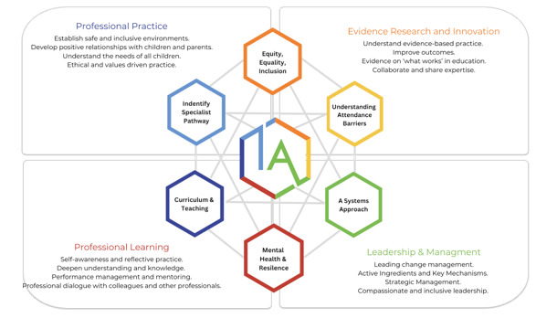

Annual Inclusive Attendance 7-Month Development Programme
Each year, each school will review and further enhance attendance practices through participation in the Inclusive Attendance 7-month development programme.

A Multi-Tiered System of Support

A Multi-Tiered System of Support for school attendance involves three tiers of intervention, with roles for teachers, the school, children, parents, and external agencies – including the Local Authority. The system aligns with the Department for Education's (DFE) "Working Together to Improve School Attendance" statutory guidance 2024.

Tier 1 - Universal Approach: Establishing a baseline universal attendance approach that benefits all children.

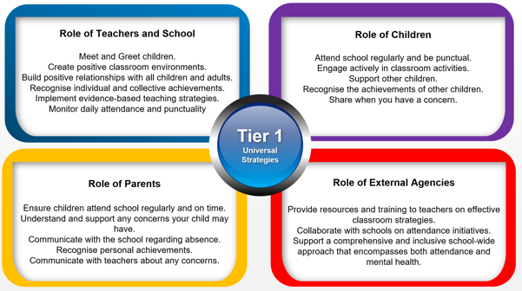

Tier 2 – Internal individualised Strategies and Early Help Support: Tailoring strategies to individual needs and providing early help support for persistent attendance challenges.

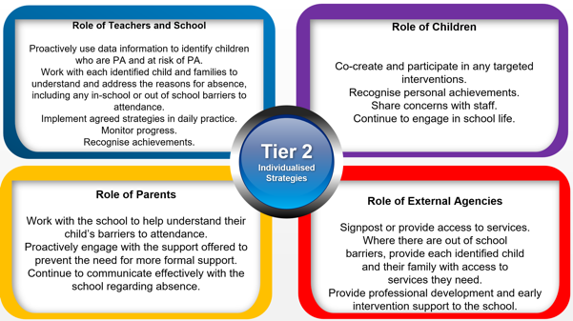

Tier 3 - Higher Needs Strategies Support: Furnishing specialised support for children, young people, and families with complex attendance requirements, including access to external agency support when necessary.

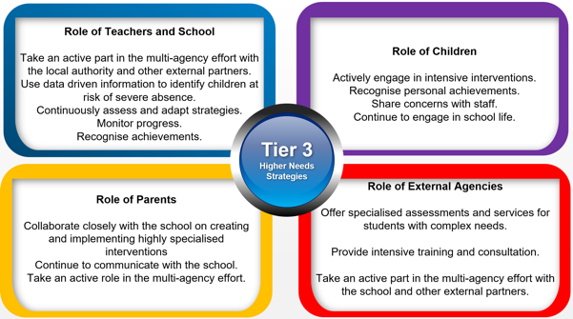

A Recognition-Based Approach
The Inclusive Attendance philosophy is rooted in a recognition-based approach that recognises both personal and collective achievements. This approach serves to cultivate positive environments, nurture relationships, foster inclusivity, and motivation among our children, families, and staff.

Recognition in our schools may include,
- Class mention in assembly
- Class certificate
- Individual mention in assembly
- Individual certificate
- A message of recognition home via text, class dojo, phone call or letter

Sometimes, small, low or no cost rewards may be utilised where this significantly motivates the child or their class to be in school. These rewards may include,
- Stickers
- ClassDojo points
- Small prize
- Extra playtime
- Other privilege or responsibility

