Norfolk Community Primary School – Y5 overview
Subject |  | Autumn 1  Tuesday 1 September 2026 until Friday 23 October 2026  (8 weeks) | Autumn 2  Monday 2nd November 2026 until Friday 18 December 2026  (7 weeks) | Spring 1  Monday 4th January 2027 until Friday 12th February 2027  (6 weeks) | Spring 2  Monday 22nd February 2027 until Thursday 25th March 2027  (5 weeks) | Summer 1  Monday 12th April 2027 until Friday 28th May 2027  (7 weeks) | Summer 2  Monday 7th June 2027 until Wednesday 21st July 2027  (6 weeks2 days)
 |  | Peace and Freedom | Sustainability and Environment | Equality and Social Justice | Diversity and Identity | Participation and citizenship | Health and wellbeing
Big idea text |  | Text – The silence seeker  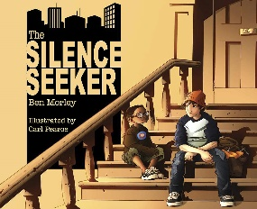 | Text - We Are Water Protectors  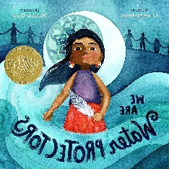 | Text – Hidden Figures  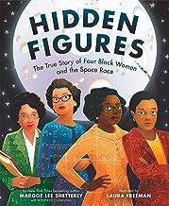 | Text - We are all different  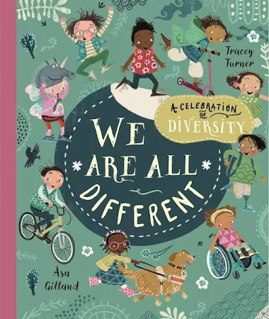 | Text – V is for Voting  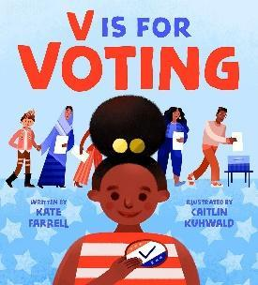 | Text -All Bodies and Wonderful by Beth Cox  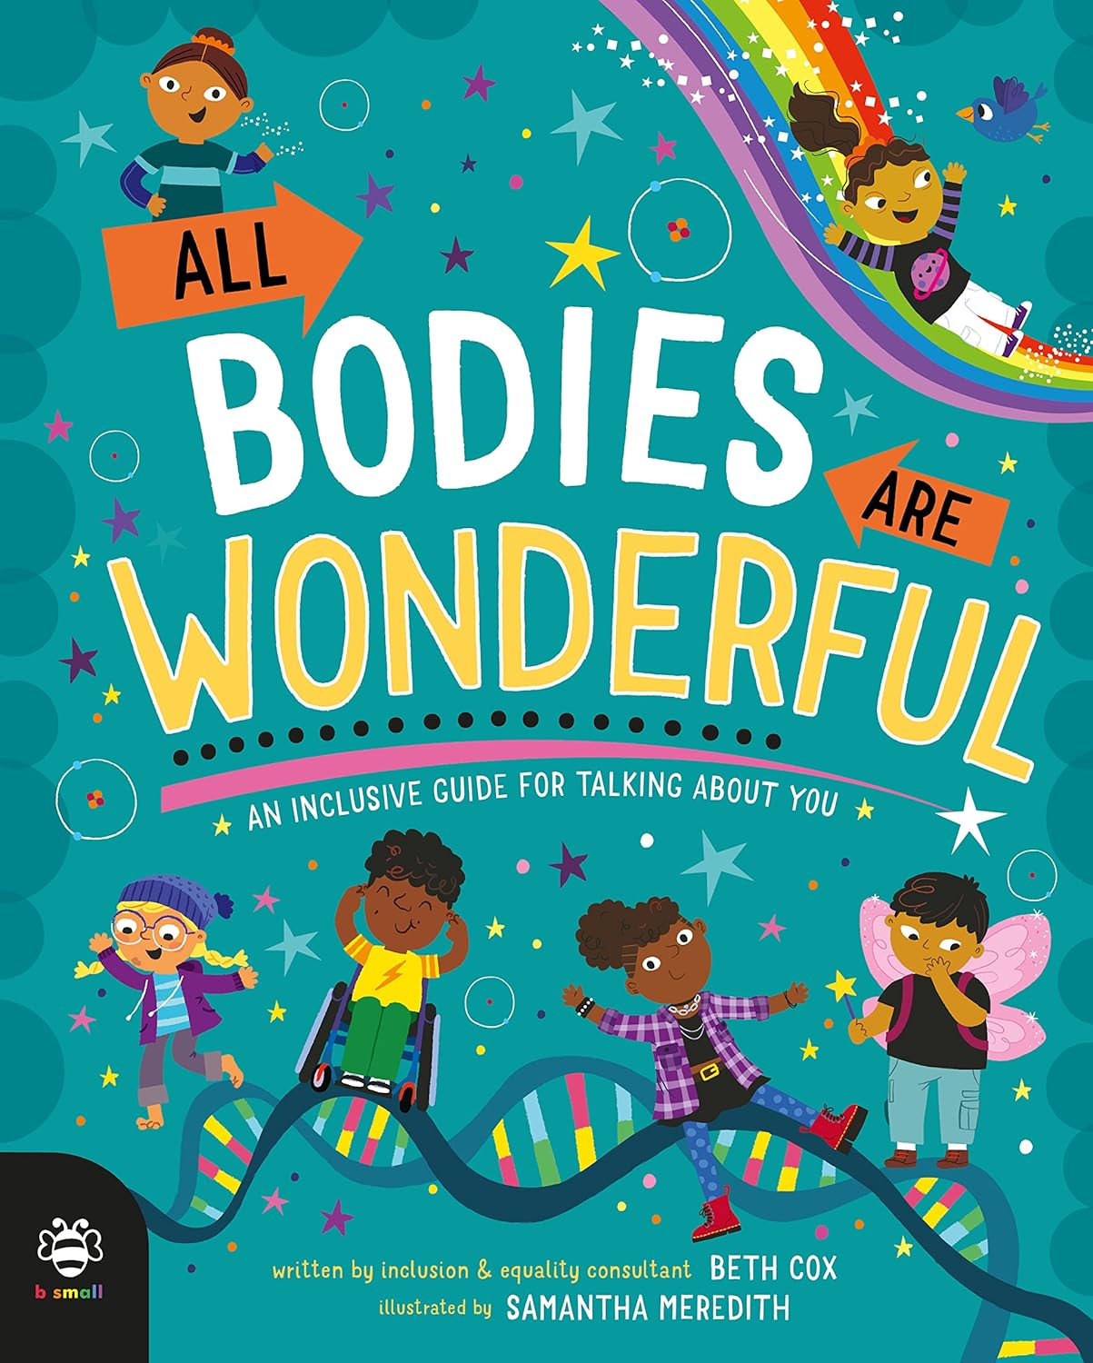
English  Writing and reading |  | Whole class reading  Anglo Saxon boy  Non fiction – Viking text | Whole class reading  Floodlands | Whole class reading  Big ideas – Hidden figures (Friday reading)  Cosmic | Whole class reading  The Explorer | Whole class reading  Nowhere emporium | Whole class reading  Skellig
 |  | Writing  Silence Seeker – Setting description 2 weeks  Narrative - Anglo Saxon Boy (3 wks)  (2 more paragraphs)  Non fiction – Persuasive speech Viking and Anglo Saxons (3wks) | Writing  Poetry – My heart is a poem (1 week)  Narrative – Floodlands – character description  Non – Fiction  Letter writing | Writing  Non-fiction: Journal recount  Write a Mission Vlog from Mars to Earth.  “Sol 2 – My first Day on Mars”  Students write a mission log recounting what happened the previous day.  “Sol 500 – My Last Day on Mars”  Students write a final mission log as the astronaut prepares to leave.  Focus: first-person voice, feelings, time adverbials.  Narrative  Science fiction Adventure story – Cosmic  New chapter  Describing what it is like being in space. The rocket malfunctions and has to land on an unknown planet. Lot of opportunities for drama. | Writing  Narrative  Adventure story – Explorer - scene adding dialogue to build tension  Non-fiction:  Newspaper paper report about missing children  (Based on the children in Explorer) | Writing  Narrative  Nowhere emporium – A paragraph to describe a new room of wonder from a characters point of view  Non fiction –Biography about Mr Silver | Writing  Fiction: Poetry – Highwayman  Retelling story fom characters point of view  Non fiction – Diary from Michaels point of view linked to Skellig
Mathematics |  | Place Value  Addition & Subtraction | Multiplication & Division  Fractions | Multiplication & Division  Fractions | Decimals & Percentages  Perimeter & Area  Statistics | Shape  Position & Direction  Decimals | Negative Numbers  Converting Units  Volume
History |  | British History Study  The Viking and Anglo-Saxon struggle for the Kingdom of England  What were the effects of Anglo-Saxon, Viking and Scots settlement in Britain? |  | Significant Individuals  Katherine Johnson  The Space race - significant individuals  Who are the significant individuals in the history of space exploration? |  | International History Study  A non-European society that provides contrasts with British history – Mayan civilization c. AD 900.
Geography |  |  | Why is Earth nicknamed the Blue Planet?  Focus on Bodies of water around the world, Water cycle, rivers and water pollution. Where does our water in our houses come from? |  | Where in the world is Brazil?  Focus on comparing South America – Brazil and Sao Paulo or Rio de Janeiro |  | Map skills  https://www.rgs.org/schools/resources-for-schools/map-skills
Science |  | Properties and Changes of Materials | Living Things and Their Habitats – life cycles | Earth and Space | Forces | Living Things and Their Habitats – Plants and human reproduction | Animals, including Humans  Getting older
RSHE |  | M1) Does everybody have the same feelings?  M2) Should we be happy all the me?  Fa1) Why do people get  married? | Os1) Control and consent  Os2) Protecting our identity  Os3) Meeting strangers online  Os4) Personal Information, terms and conditions | C1) What is prejudice?  C2) What is the history of prejudice?  C3) What should I do if I encounter prejudice? | P1) Is there such a thing as the perfect body?  P2) How can I stay fit and healthy?  P3) Can I avoid getting ill? | Fr1) What makes a close friend?  Fr2) Should I try and fit in with my friends?  Fr3) Should friends tell us what to do? | FIRST AID (2 lessons)  G1) How will my body change as I get older?  G2) How will my feelings change as I get older?  G3) How will I stay clean during puberty?  G4) What is Menstruation?
RE |  | U2.1 What does it mean if Christians believe God is holy and loving?  (2 lessons) | U2.10 What matters most to Humanists, Christians? Christians and non-religious, with opportunities to include other religions studied (trip and 2 lesson) | U2.7 Why do Hindus want to be good? (3 lessons) | U2.5 What do Christians believe Jesus did to ‘save’ people?  (2 lessons) | U2.8 What does it mean to be a Muslim in Britain today?  (1 day | ) U2.12 How does faith help people when life gets hard? Christians, Muslims and/or Jews and/or Hindus, non-religious (3 lessons)
Art |  | Printing - art day  Key concepts - colour, pattern | Painting  Concepts – Colour, pattern and texture  Theoretical Knowledge - Artists  Pointilism – Georges Seurat  Post impressionism – Van Gogh  Impressionism – Monet  Aboriginal water art  Alma Thomas – abstract  Looking at how water is painted in a variety of different movements. | Mixed media – Art day  Peter Thorpe space art work | Drawing  Concepts – Line, pattern and shape  Theoretical Knowledge - Artists  Yayoi Kusama's dotty patterns  Friedensreich Hundertwasser – abstract landscapes | Sculpture  Concepts – form and space and pattern  Theoretical Knowledge - Artists  Variety of Mayan Theoretical Knowledge - Artists  Henry Moore  Diversity - Caroline Achaintre  Make Maya Masks out of Modroc  Use colour | Collage Art day – transition  Y5 - The Superpower of Looking: a powerful portrait by Kehinde Wiley | Art UK  Y5 – Picasso
DT |  | Mechanical systems: Making a pop-up book (Lessons 1 - 3; omit lesson 4) NB. Use the Jack and Jill book and moving parts template in Lesson 2, to reduce time  Electrical systems: Doodlers (Lessons 1 - 3; omit lesson 4) | Cooking - skills | Structures: Bridges (4 lessons) | Cooking and nutrition: What could be healthier? (2 lessons in 1 day) | Links to fair trade food  Cooking and nutrition: What could be healthier? (2 lessons in 1 day) | Digital world: Monitoring devices (4 lessons)
Music |  | Composition Notation (Theme; Ancient Egypt) | Blues | South and West Africa | Composition to represent the festival of colour (Theme: Holi Festival) | Looping and remixing | Musical Theatre
Computing |  | Systems and searching | Selection in physical computing | Creating media – video production | Flat-file databases |  | Selection in quizzes
PE | In | Sports Hall Athletics | Dance | Gymnastics | Dance | Tennis | Gymnastics
PE | Out | Basketball | Volleyball | Tag Rugby | Handball | Athletics | Cricket

