Norfolk Community Primary School – Y6 overview
Subject |  | Autumn 1  Tuesday 1 September 2026 until Friday 23 October 2026  (8 weeks) | Autumn 2  Monday 2nd November 2026 until Friday 18 December 2026  (7 weeks) | Spring 1  Monday 4th January 2027 until Friday 12th February 2027  (6 weeks) | Spring 2  Monday 22nd February 2027 until Thursday 25th March 2027  (5 weeks) | Summer 1  Monday 12th April 2027 until Friday 28th May 2027  (7 weeks) | Summer 2  Monday 7th June 2027 until Wednesday 21st July 2027  (6 weeks2 days)
 |  | Peace and Freedom | Sustainability and Environment | Equality and Social Justice | Diversity and Identity | Participation and citizenship | Health and wellbeing
Big idea text |  | Text – The Journey by Francesca Sanna  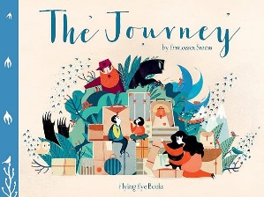 | The Rabbits by Shaun Tann  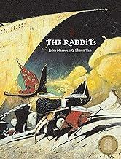 | Rose Blanche  by Ian McEwan and Roberto Innocenti  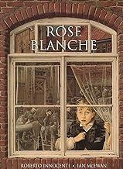 | Frankie's World By Aoife Dooley  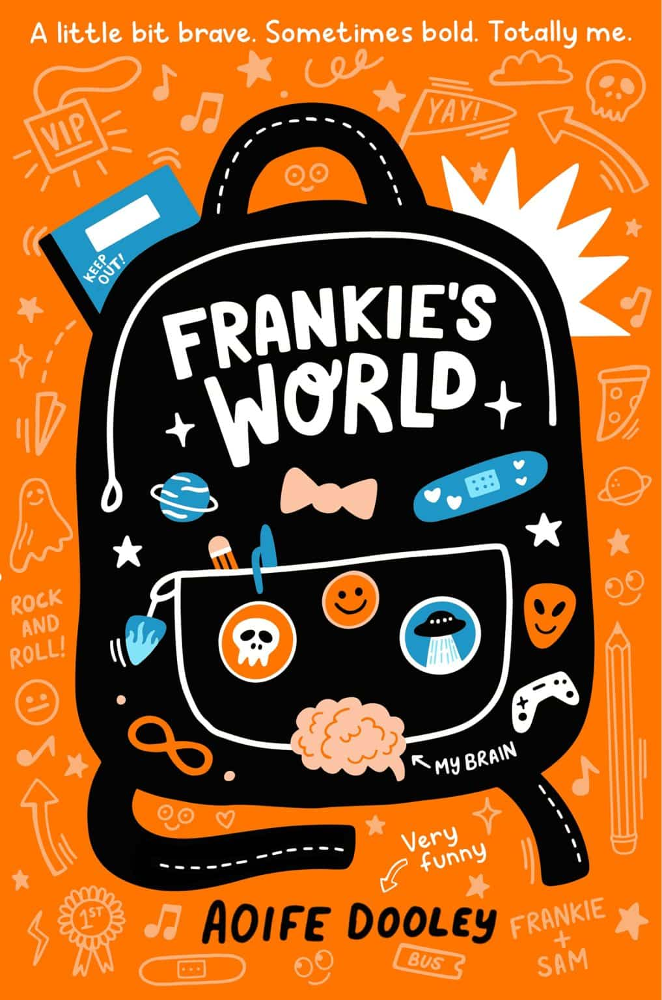 | Dissent: Ruth Bader Ginsburg Makes Her Mark  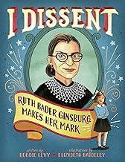 | Kay’s Anatomy  by Adam Kay  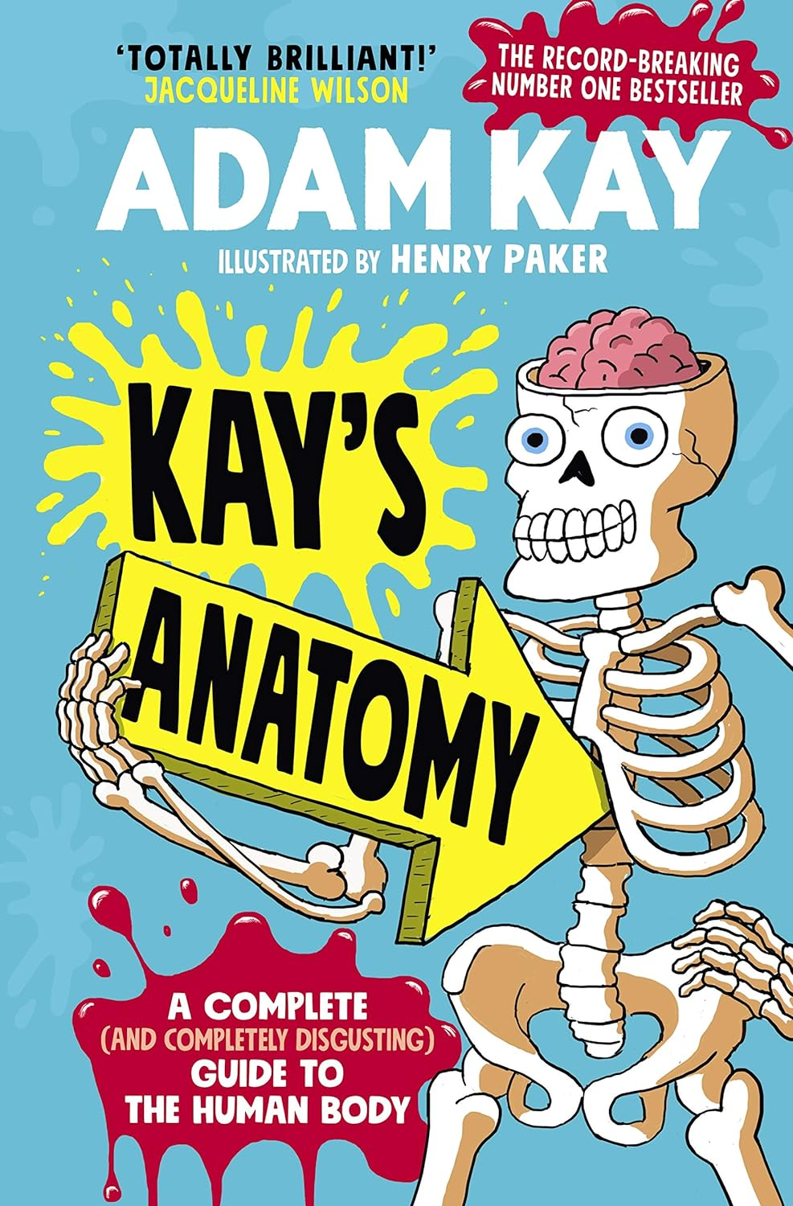
English  Writing and reading |  | Whole class reading  Welcome to Nowhere  Elizabeth Laird | Whole class reading  The last bear | Whole class reading  Letter from the lighthouse | Whole class reading  Stormbreaker | Whole class reading  The final year | Whole class reading  Pig heart boy
 |  | Writing lesson  Fiction – The journey (3 weeks)  Fiction - Welcome to Nowhere  Elizabeth Laird (3 weeks)  Non fiction – Informal letter (2 weeks) | Writing  Narrative - The last bear – setting description and dialogue and scene. (3 weeks)  Non fiction – Non Chronological report - The last bear (polar bear)  (3 weeks) | Writing  Narrative – Rose Blanche  Character description -  Character description – Explore the character of Rose Blance thorough character profile activity and first person monologue.  Use this to write an evidence-based character description. Use a moment in the story where Rose shows her qualities. Re-write the scene describing Rose using show not tell.  Recount (Interview) -  Letters from a Lighthouse  See box below:  Recount - 3 weeks  Letters from the Lighthouse – Emma Carroll – Recount Interview  Use drama - Character of the reporter  Build up the purpose of the interview – what is the reporter trying to establish.  Write an interview between the reporter and an evacuee. Focus on the questions and digging deeper into the follow-up questions. | Writing  Narrative– Stormbreaker  Dialogue to move action on  Non fiction – Persuasive text for a spy Gadget | Writing  Narrative - The final year  A diary entry written in role as Nate, describing an important moment in the story (e.g., argument with PS, worries about Dylan, or feelings about Year 6).  Narrative Digital literacy Francis – Reports using different tones  Non fiction – Balanced argument | Writing  Pig heart boy - dialogue  Non-fiction - Formal and informal letters linked to pig heart boy
Mathematics |  | Place Value  Calculations | Fractions  Converting Units | Ratio  Algebra  Decimals | Fractions, Decimals. Percentages  Area, Perimeter, Volume  Statistics | Shape  Position & Direction | Project Work
History |  | A study of an aspect or theme in British history that extends pupils’ chronological knowledge beyond 1066  Journeys: the story of migration to Britain  Why did migrants come to Britain and how have they changed Britain? 2024/25 (move autumn 1 2025/26) |  | A study of an aspect or theme in British history that extends pupils’ chronological  knowledge beyond 1066  How did the experience of British people differ to other places in Europe during World war 2? |  | TBC
Geography |  |  | How can we save our Biomes?  Focus on physical geography, including: climate zones, biomes and vegetation belts. |  | Are humans destroying our planet?  Focus on how climate varies and how we are affecting it |  | Map skills  https://www.rgs.org/schools/resources-for-schools/map-skills
Science |  | Electricity | Living Things and their Habitats – classification | Light | Evolution and Inheritance | Animals, including Humans  Circulatory system, healthy living and nutrients
RSHE |  | M3) Why do we argue?  M4) Who am I? | Os5) Analysing Digital Media  Os6) Bias  Os7) Echo Chambers  Os8) Does the internet make us happy? | Fr4) Why are some people unkind?  Fr5) What are stereotypes?  Fr6) How do I accept my friends for who they are? | Fa2) Are families ever perfect?  Fa3) Is there such a thing as a normal family? | C5 Why is money important?  C6) Who belongs in our country?  C7) What does it mean to be British? | FIRST AID (2 lessons)  P4) Why do some people take drugs?  P5) Where should I get my health information?  P6) How do I save a life?  Recap G1 and G2  Sx1 and Sx2 Optional
RE |  | U2.6 For Christians, what kind of king is Jesus? (4 lessons) | U2.2 Creation and science: conflicting or complementary?  (3 lessons) | U2.4 How do Christians decide how to live? ‘What would Jesus do?’ (3 lessons | 2.3 Why do Christians believe Jesus was the Messiah? (1 lesson) | U2.9 Why is the Torah so important to Jewish people?  (2 lessons) | U2.11 Why do some people believe in God and some people not? Christians, non-religious (2 lessons)
Art |  | Printing - art day  Key concepts - colour, pattern | Painting  Concepts – Colour, pattern and texture  Theoretical Knowledge - Artists  L.S Lowry  Period: Naïve art  Archibold Motley – American visual artist  Harlem Renaissance movement  David Hepher's Arrangement in Turquoise and Cream,  on perspective.. | Textiles  Make do and mend  Concepts - pattern, texture | Drawing  Concepts – Line, pattern and shape  Theoretical Knowledge - Artists  Paul Cezanne (landscapes)  J. M. W. Turner's 1844 painting Rain, Steam, and Speed – The Great Western Railway. – perspective | Sculpture  Concepts – form and space and pattern  Theoretical Knowledge - Artists  Alberto Giacometti  Anthony Gormley  Diverse  Jennifer Watt  Sculpture– Bodies  Create human bodies showing movement using wire and Modroc | Collage Art day – transition  Y6 - Hannah Hoch
DT |  | Structure: Playgrounds (Lessons 1 - 3; omit lesson 4) NB. Skip the surrounding landscape and complete the playground structures in lesson 3  Electrical systems: Steady hand game (Lesson 2 - 4; omit lesson 1) | Cooking - skills | Mechanical systems: Automata toys (4 lessons) | Cooking and nutrition: Come dine with me (2 lessons in 1 day) | Cooking and nutrition: Come dine with me (2 lessons in 1 day) | Digital world: Navigating the world (5 lessons) NB: You could complete lesson 5 as an assembly or celebratory event.
Music |  | Dynamics, pitch and texture (Theme: Fingal’s Cave) | Songs of WW2 | Film Music | Theme and variations (Theme: Pop Art) | Baroque | Composing and performing a Leavers’ Song
Computing |  | Communication  and collaboration | Variables in games | Creating media  Webpage creation | Introduction to  spreadsheets |  | . Sensing movement
PE | In | Sports Hall Athletics | Dance | Gymnastics | Dance | Tennis | Gymnastics
PE | Out | Football | Badminton | Hockey | Netball | Athletics | Rounders

