Norfolk Community Primary School – Y1 overview

Subject |  | Autumn 1  Tuesday 1 September 2026 until Friday 23 October 2026  (8 weeks) | Autumn 2  Monday 2nd November 2026 until Friday 18 December 2026  (7 weeks) | Spring 1  Monday 4th January 2027 until Friday 12th February 2027  (6 weeks) | Spring 2  Monday 22nd February 2027 until Thursday 25th March 2027  (5 weeks) | Summer 1  Monday 12th April 2027 until Friday 28th May 2027  (7 weeks) | Summer 2  Monday 7th June 2027 until Wednesday 21st July 2027  (6 weeks2 days)
 |  | Peace and Freedom | Sustainability and Environment | Equality and Social Justice | Diversity and Identity | Participation and citizenship | Health and wellbeing
Big idea text |  | Text - Peace on Earth  Author: Smriti Ha  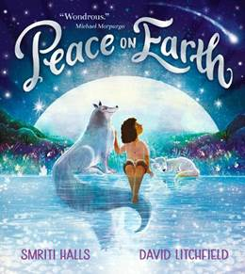 | Text –Leaf  By Sandra Dieckmann  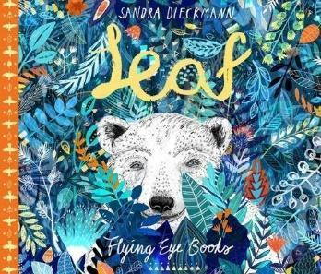 | Text – Coming to England By Floella Benjamin  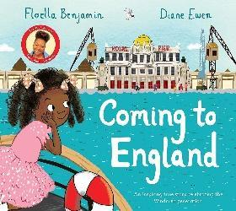 | Text -Odd Dog Out by Rob Biddulph  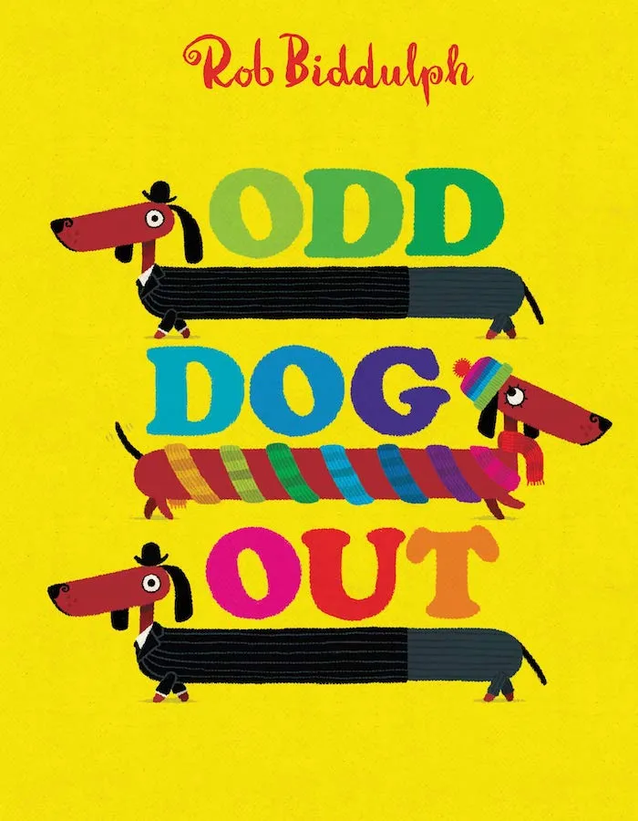 | Text – Wanda  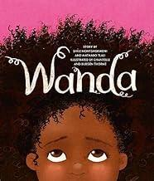 | Text - Oliver’s Vegetables  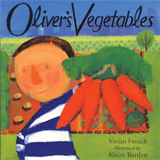
English  Writing and reading |  | Main text - Music in the round text  Fiction – Storm Whale  Fiction - Peace on Earth  Author: Smriti Halls  Poetry  Autumn poems  Zim Zam Zoom (1 week) | Main text – Leaf  Fiction – Leaf  Non-Fiction – Instruction Writing (Making leaf puppets)  Poetry – Winter (Seasons – science link) | Main text Coming to England  Non fiction text - Bold women in Black history –  Fiction – Hansel And Gretel by Rachel Isadora | Main text - Odd dog out  3 weeks  Fiction – Rapunzel  By Bethan Woolvin  Non fiction – How to look after a guinea pig – use school guinea pigs and visit class, look at their cage, food, bedding. Use RWI how to look after a hamster as an e.g. | Main text – Pattan’s Pumpkin  Fiction – Pattan’s Pumpkin  Non fiction text – Instructions - making soup | Main text – Jack and the Beanstalk  Non fiction text – bean diaries – Growing – science link)  Poetry – transition
Mathematics |  | Place Value | Addition & Subtraction  Shape | Place Value  Addition & Subtraction | Place Value  Length & Height  Mass & Volume | Multiplication & Division  Fractions  Position & Direction | Place Value  Money  Time
History |  | Changes within Living Memory  Family Life: houses and toys  How has family life changed since the 1950’s? |  | Significant Individuals  Martin Luther King  Floella Benjamin  How were these people significant? |  | Changes within Living Memory  How have seaside resort changed in the last 50 years?  Significant Individuals  Who was Grace Darling and what did she do to help others?
Geography |  |  | How are places around the world different?  Focus on hot and cold places |  | Where would I like to visit in the UK?  Focus on the Seaside resorts in UK. |  | Map skills  https://www.rgs.org/schools/resources-for-schools/map-skills
Science |  | Everyday Materials | Seasonal changes | Animals, - Common Animals | Plants |  | Humans- Body Parts
 |  | Seasonal changes: • Observe changes across the four seasons • Observe and describe weather associated with the seasons and how day length varies.
RSHE |  | M1) Where do feelings come from?  M2) Who am I? | Os1) Screen time (L1)  Os2) Personal information (S1 | Fr1) Who is my friend?  Fr2) What makes a good friend? | Fa1) Who’s in my family?  Fa2) Do Families always stay the same?  Fa3) How should families treat each other? | C1) How do we make a happy school?  C2) Who lives in my neighbourhood? | FIRST AID (2 lessons)  P1) How do I help my body stay healthy?  P2) How do I decide what to eat?
RE |  | 1.1 What do Christians believe God is like? (2 lessons and trip) | 1.2 Who do Christians say made the world? (2 lessons)  1.3 Why does Christmas matter to Christians? (literacy) |  | 1.5 Why does Easter matter to Christians? (1 day) | 1.6 Who is Muslim and how do they live?  (3 lessons and visitor)
Art |  | Printing Art day  Key concepts - colour, pattern | Painting  Concepts – Colour, pattern  Theoretical Knowledge - Artists  Paul Klee – seasonal landscapes  Anne Estelle Rice – Seasonal Landscapes (post impressionist) | Digital media Art day  Key concepts - colour, pattern  Creating Media - Digital painting  Linked to Martin Luther King  Martin Luther King Jr. Portrait Art Project | Deep Space Sparkle | Drawing  Concepts – Line, pattern and shape  Theoretical Knowledge - Artists  Picasoo ( use of line)  Paul Klee (line drawings) | Sculpture  Concepts – form and space  Theoretical Knowledge - Artists - Anthony Gormley | Collage Art day – transition  Y1 – Eric Carle collages
DT |  | Mechanisms: Moving story book (Lesson 1 - 3; omit lesson 4) NB: Use the Storybook template (see Resources) for all pupils in Lesson 2 to save time.  Structures: Constructing windmills (Lesson 1 - 3; omit lesson 4) | Cooking - skills | Mechanisms: Wheels and axles (4 lessons) | Cooking and Nutrition: Fruit and Vegetables (2 lessons on 1 day) Links to fair trade food | Cooking and Nutrition: Fruit and Vegetables (2 lessons on 1 day) | Textiles: Puppets (4 lessons)
Computing |  | Technology around us  Recognising technology in school and using it responsibly | Moving a robot  Writing short algorithms and programs for floor robots, and predicting program outcomes. |  | Grouping data  Exploring object labels, then using them to sort and group objects by  properties. |  | Programming  animations  Designing and  programming the  movement of a character on screen to tell stories.
Music |  | Keeping the pulse (My favourite things) | Temp (Snail and mouse) | Dynamics (Seaside) | Sound patterns (Fairytales) | Pitch (superheroes) | Musical symbols (Under the sea)
PE | In | Fundamentals | Dance | Gymnastics | Dance | Target Games | Gymnastics
PE | Out | Team Building | Sanding and Receiving | Ball Skills | Invasion Games | Athletics | Striking and Fielding Games
;.’/

