Norfolk Community Primary School – Y2 overview
Subject |  | Autumn 1  Tuesday 1 September 2026 until Friday 23 October 2026  (8 weeks) | Autumn 2  Monday 2nd November 2026 until Friday 18 December 2026  (7 weeks) | Spring 1  Monday 4th January 2027 until Friday 12th February 2027  (6 weeks) | Spring 2  Monday 22nd February 2027 until Thursday 25th March 2027  (5 weeks) | Summer 1  Monday 12th April 2027 until Friday 28th May 2027  (7 weeks) | Summer 2  Monday 7th June 2027 until Wednesday 21st July 2027  (6 weeks2 days)
 |  | Peace and Freedom | Sustainability and Environment | Equality and Social Justice | Diversity and Identity | Participation and citizenship | Health and wellbeing
Big idea text |  | Text -  My name is not refugee  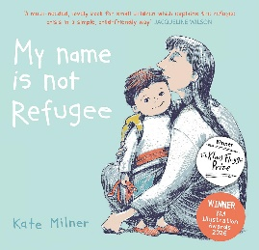 | Text –  The Tin Forest  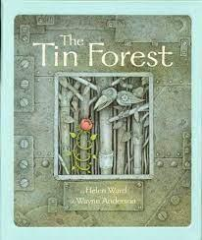 | Text – Maya Angelou –Little people, big dreams  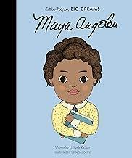 | Text - The Proudest Blue  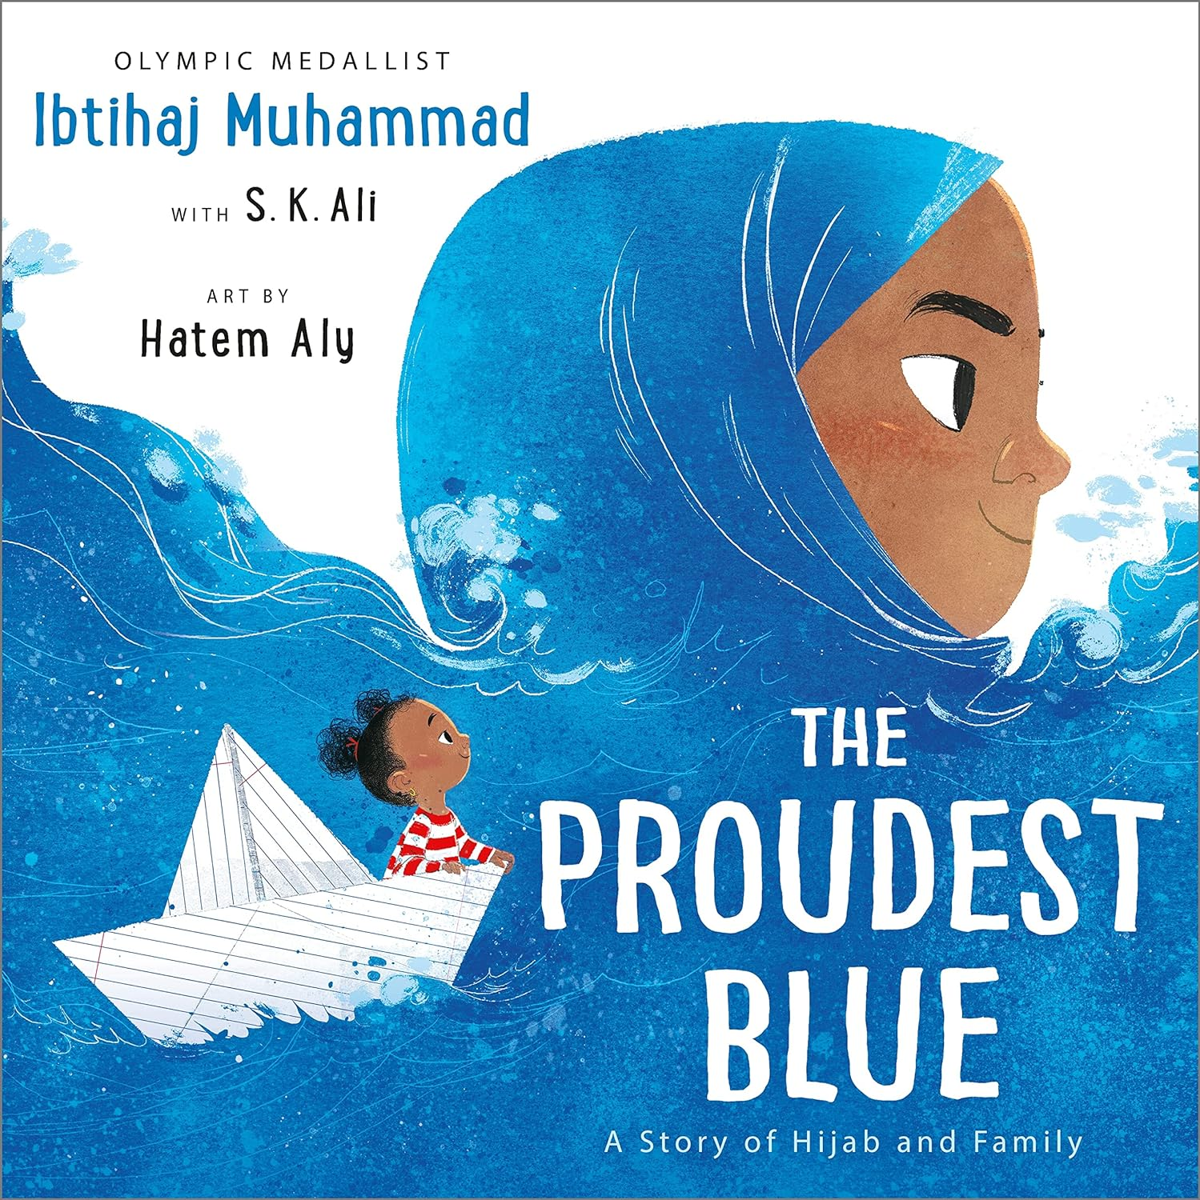 | Text – What can a citizen do?  By Dave Eggers  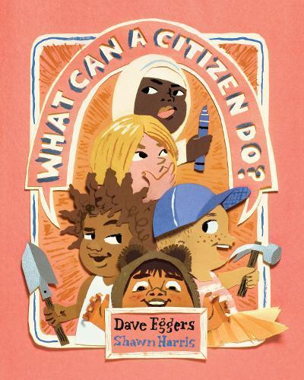 | Text - The busy body book  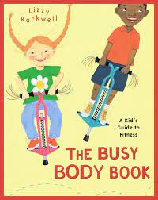
English  Writing and reading |  | Main text – The Dark  Fiction – The dark – narrative  Non fiction – Instructions – How to make a glow jar.  Poetry- Smile Aloud | Main text –Tin Forest  Fiction – Tin Forest  Non-Fiction- Woodland Habitats and animals  Poetry – Smile out Loud | Main text – The day the crayons quit  Fiction – The day the crayons quit  Non fiction Factfile – Florence Nightingale  Letter – Florence | Main text – The crow’s tale  Fiction- The Crow’s Tale  Non-Fiction – Change  Food and nutrition?  Instructions? | The Invincibles  Fiction – Olga da Polga -  Non Fiction – Great Fire of London Diary | Big ideas – The busy body book  Fiction – The Secret of Black Rock – Joe Todd Stanton - Descriptive focus (character/ setting) Narrative – retelling part of a story  ++  Non Fiction – Animal fact file Big Cats - JC  Poetry- Smile out loud
Mathematics |  | Place Value  Addition & Subtraction | Addition & Subtraction  Shape | Money  Multiplication & Division | Length & Height  Mass, Capacity & Temperature | Fractions  Time | Statistics  Position & Direction
History |  | Significant historical events, people and places in their own locality.  Victorian children - schools, factories  What was life like for children in Victorian times? |  | Significant Individuals  In what ways were Florence Nightingale and  Mary Seacole similar and how are they significant? |  | Events Beyond Living Memory  The Great Fire of London
Geography |  |  | How do maps help us to learn about different places?  Focus on the UK and our school |  | What is life in the city?  Focus on a comparison between Sheffield and Beijing |  | Map skills  https://www.rgs.org/schools/resources-for-schools/map-skills
Science |  | Uses of Everyday Materials | Living Things and Their Habitats |  | Plants |  | Animals, including humans  Offspring, staying healthy
RSHE |  | Recap M2  M3) What helps me to be happy? | Os3) Online strangers  Os4) Fake News (N1) | Fr3) Should friends tell  us what to do?  Fr4) How do we stop  bullying? | Fa6) Are all families the same | Recap C2  C3) What makes a boy or a girl? | FIRST AID (2 lessons)  P3) How do we stop getting ill?  P4) How can I stay safe?
RE |  | 1.7 Who is Jewish and how do they live? (5 lessons) | 1.9 How should we care for others and for the world, and why does it matter? Christians, Jews and non-religious worldviews  (1 day need start of half term) | 1.4 What is the ‘good news’ Christians believe Jesus brings? (3 lessons) |  | 1.10 What does it mean to belong to a faith in a community? (3 lessons) | 1.8 What makes some places sacred to believers?  (2 lessons and a trip or visitor)
Art |  | Printing – art day –  Key concepts - colour, pattern | Painting  Concepts - Colour, shape and pattern linked to mood and the environment  Theoretical Knowledge - Artists – Abstract art  Kandinsky painting  Hilma of Klint | Digital media - Art day  Creating media  Digital photography | Drawing  Concepts – Line, pattern and shape  Draw figures (inspired by drawings of Florence Nightingale)  Theoretical Knowledge - Artists  Van Gogh – self portrait drawings | Sculpture  Concepts – form and space  Clay tiles based on topic – How does my garden grow  Theoretical Knowledge - Artists  Laura Bethmann  Diversity  Mairie Stone | Collage Art day – transition  Y2 – Eileen Agar
DT |  | Structures: Baby bear's chair (Lesson 2 - 4; omit lesson 1)  Textiles: Pouches (Lessons 1 – 3; omit lesson 4) | Cooking - skills | Mechanisms: Fairground wheel (4 lessons) | Links to fair trade food  Cooking and nutrition: A balanced diet (2 lessons in 1 day) | Cooking and nutrition: A balanced diet (2 lessons in 1 day) | Mechanisms: Moving monster (4 lessons)
Music |  | Call and response (Animals) | Instruments (Musical storytelling) | Singing (on the island) | Contrasting dynamics (Space) | Structure (Myths and Legends) | Pitch (Musical Me)
Computing |  | Information technology around us | Robot algorithms | Digital media linked to art - Digital photography | Pictograms |  | Programming quizzes  .
PE | In | Fundamentals | Dance | Gymnastics | Dance | Target Games | Gymnastics
PE | Out | Team Building | Sending and Receiving | Ball Skills | Invasion Games | Athletics | Striking and Fielding Games

