Norfolk Community Primary School – Y3 overview
Subject |  | Autumn 1  Tuesday 1 September 2026 until Friday 23 October 2026  (8 weeks) | Autumn 2  Monday 2nd November 2026 until Friday 18 December 2026  (7 weeks) | Spring 1  Monday 4th January 2027 until Friday 12th February 2027  (6 weeks) | Spring 2  Monday 22nd February 2027 until Thursday 25th March 2027  (5 weeks) | Summer 1  Monday 12th April 2027 until Friday 28th May 2027  (7 weeks) | Summer 2  Monday 7th June 2027 until Wednesday 21st July 2027  (6 weeks2 days)
 |  | Peace and Freedom | Sustainability and Environment | Equality and Social Justice | Diversity and Identity | Participation and citizenship | Health and wellbeing
Big idea text |  | Text - Dreams of freedom  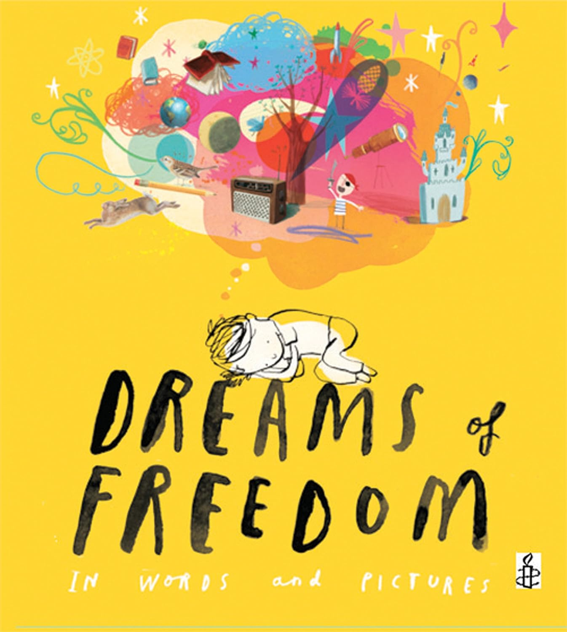  -/+= | Text – Nicola Davis  The Promise  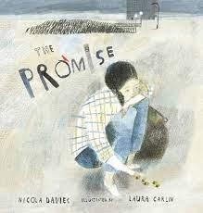 | Text – Something Else  Kathryn Cave and Chris Riddell  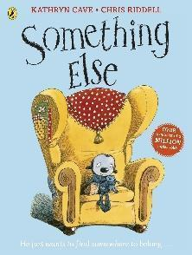 | Text -Shine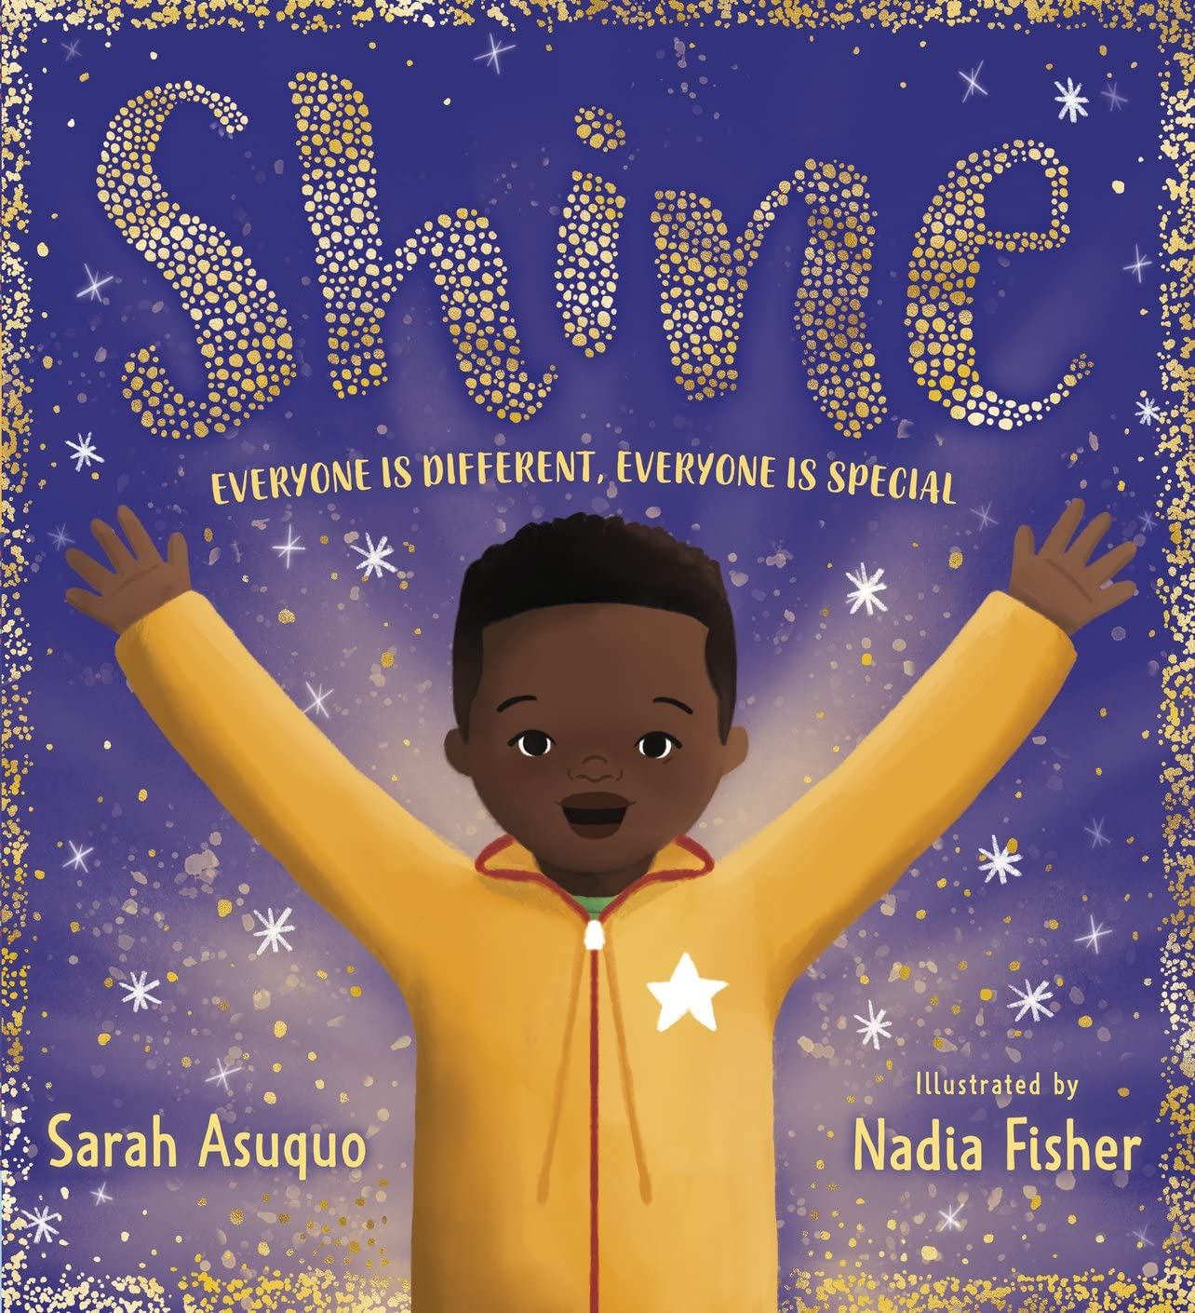 | Text – The invisible  By Tom Percival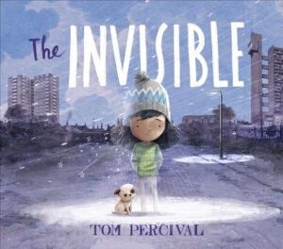 | Text -  Couch Potato  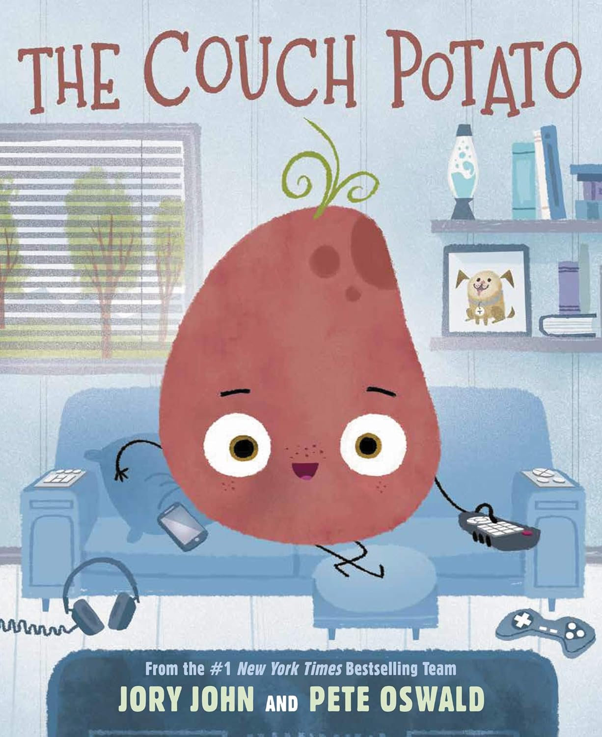
English  Writing and reading |  | Whole class reading  Call me lion | Whole class reading  Firework makers daughter | Whole class reading  I was a rat - Philip Pullman | Whole class reading  The wild robot | Whole class reading  The boy who grew dragons | Whole Class Reading – The Iron Man
 |  | Writing lessons  Fiction - Fly Eagle Fly  Continue the Story  Students write what happens after the eagle flies away. Does he come back? Does he find others like him? What adventures might he have?  Fiction - A short chapter when Richa meets Leo (from Richa’s point of view)  Non Fiction - Diary entries Leo worried about losing Richa’s friendship - encouragement to explore emotive and sensory details. | Writing lessons  Narrative The promise  Character Description  Write a descriptive paragraph about the main character before and after they make the promise, showing how they change.  Use adjectives and similes/metaphors to describe character development.  Non fiction – A Job Description for a Firework Maker  Write a job description that includes:  What skills they need?  What they will do each day? Why the job is important?  Poetry – Writing firework poetry | Writing lessons  Narrative - Write from Roger’s Perspective  Day in the life as a rat.  Ask the students to imagine they are Roger, the boy who claims he was once a rat. Write a short story describing a day in Roger’s life. Encourage them to include:  - How he feels being different  - What it’s like to try to explain to people that he was a rat  - Any adventures or troubles he gets into  Non fiction –Persuasive leaflet - Why should women have equal rights. Write from a point of view of a Suffragettes. | Writing lessons  Narrative - The wild robot. A Storm on the Island  Write a story about a big storm that hits the island. How does Roz help the animals? What problems do they face?  Non fiction  Instruction Writing: How to Survive on a Wild Island | Writing lessons  Narrative - Marcy and the riddle of the sphinx  Marcy’s New Adventure After solving the riddle of the Sphinx, Marcy finds another hidden door in the pyramid. What does she discover behind it?  Include a new mythical creature, ancient traps, or a magical map.  Non Fiction – Non-Chronological Report  Title: All About Dragons or The Dragon Fruit Tree  - Subheadings like: Appearance, Habitat, Diet, Special Powers  - Include a labelled diagram  - Use formal, factual tone | Writing lessons  Non fiction – Eye witness report seeing the Iron Man. Children to write s positive and negative report for a village meeting.  Writing lessons  A New Arrival  One day, something strange fell from the sky — but it wasn't the Iron Man. It was something else...  Students create their own metal creature with unique powers.  Encourage them to describe how it looks, where it lands, and how the people (or Iron Man) react.
Mathematics |  | Place Value  Addition & Subtraction | Multiplication & Division | Multiplication & Division  Length & Perimeter | Fractions  Mass & Capacity | Fractions  Money  Time | Shape  Statistics
History |  | British History Study  Changes in Britain from the Stone Age to the Iron Age  How did life change between the stone age and the iron age and how do we know? |  | Significant Individuals  How have women’s rights changed since the 18th century? |  | International History Study  The achievements of the earliest civilizations – an overview of where and when the first  civilizations appeared and a depth study of Ancient Egypt
Geography |  |  | Why is our planet so hazardous?  Focus on volcanoes and Earthquakes |  | What does it look like where I live?  Focus on physical Geography of UK and our Local area – peak district  . |  | Map skills  https://www.rgs.org/schools/resources-for-schools/map-skills
Science |  | Rocks | Light | Forces and magnets | Skills | Plants | Animals, including Humans  Skeletons and muscles and nutrition
RSHE |  | M1) How do I manage my feelings? | Os1) Online strangers  Os2) Sharing Online  Os3) Friendship Online | C1) How do we make the world fair?  Fr1) What makes a good friend?  Fr2) Are all friends the same? | Fa1) Do Families always stay the same?  Fa2) Are all families like mine? | C2) Where do you feel like you belong? | FIRST AID (2 lessons)  P1) How do I keep my body healthy?  P2) How do I get a healthy diet?
RE |  | L2.7 What do Hindus believe God is like?  (4 lesson and reading lessons) | L2.1 What do Christians learn from the Creation story?  (2 lesson and reading lessons) | L2.10 How do festivals and family life show what matters to Jewish people?  (5 lessons) | L2.5 Why do Christians call the day Jesus died ‘Good Friday’?  (1 day including art) | L2.9 How do festivals and worship show what matters to Muslims?  (2 lessons and trip) | L2.3 What is the ‘Trinity’ and why is it important for Christians?  (visitor and 1 lesson)
Art |  | Printing - Art day  Key concepts - colour, pattern | Painting  Concepts – Colour, pattern and texture  Theoretical Knowledge - Artists  Jackson Pollock Abstract expressionism  Janet Sobel  Frank Bowling | Digital media  Creating media linked to computing  Stop frame animation | Drawing  Close observational drawing – still life  Concepts – Line, pattern and shape  Theoretical Knowledge - Artists  Henri Matisse – still life pencil drawings  The Superpower of Looking: Matisse and a pink tablecloth | Art UK  Georgia O’ Keefe | Sculpture  Concepts – form and space  Theoretical Knowledge - Artists  Prehistoric pottery  Egyptian pottery  Sean Forest Roberts  Diversity  Yumiko Goto  Megan Bogonovich | Collage Art day – transition  Y3 – Gees Bend Quilters
DT |  | Structures: Constructing a castle (Lessons 2 – 4; omit lesson 1)  Mechanical system: Pneumatic toys (Lessons 2 – 4; omit lesson 1) NB. Watch the tea box in lesson 1, as a physical example. | Cooking - skills | Digital world: Wearable technology (Lessons 2-5; omit lessons 1 and 6) NB. This means that there is no evaluation in the unit | Links to fair trade food  Cooking and nutrition: Eating Seasonally  (2 lessons in 1 day)  Root vegetable stew  Skills – peeling and slicing | Cooking and nutrition: Eating seasonally (2 lessons in 1 day)  Summer fruit tart  or  Summer veg tart | Textiles: Cross stitch and appliqué Cushions or Egyptian collars (4 lessons
Music |  | Ballads | Creating compositions in response to an animation (Theme: Mountains) | Developing singing technique (Theme: The Vikings) | Zootime | Friendship Group | Reflect, Rewind and Replay
French
Computing |  | Connecting  computers | Sequencing sounds | Creating media – Stop frame animation | Branching databases |  | Events and actions  in programs
PE | In | Fundamentals | Dance | Gymnastics | Dance | Tennis | Gymnastics
PE | Out | Ball Skills | Basketball | Hockey | Handball | Athletics | Cricket

