Norfolk Community Primary School – Y4 overview
Subject |  | Autumn 1  Tuesday 1 September 2026 until Friday 23 October 2026  (8 weeks) | Autumn 2  Monday 2nd November 2026 until Friday 18 December 2026  (7 weeks) | Spring 1  Monday 4th January 2027 until Friday 12th February 2027  (6 weeks) | Spring 2  Monday 22nd February 2027 until Thursday 25th March 2027  (5 weeks) | Summer 1  Monday 12th April 2027 until Friday 28th May 2027  (7 weeks) | Summer 2  Monday 7th June 2027 until Wednesday 21st July 2027  (6 weeks2 days)
 |  | Peace and Freedom | Sustainability and Environment | Equality and Social Justice | Diversity and Identity | Participation and citizenship | Health and wellbeing
Big idea text |  | Text – The day the war came  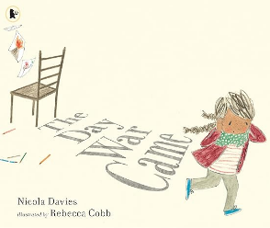 | Text – Greta and the Giants  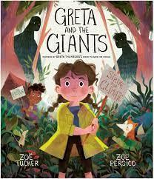 | Text - Malala's Magic Pencil  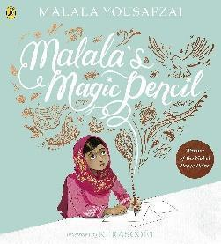 | Text -The Day you Begin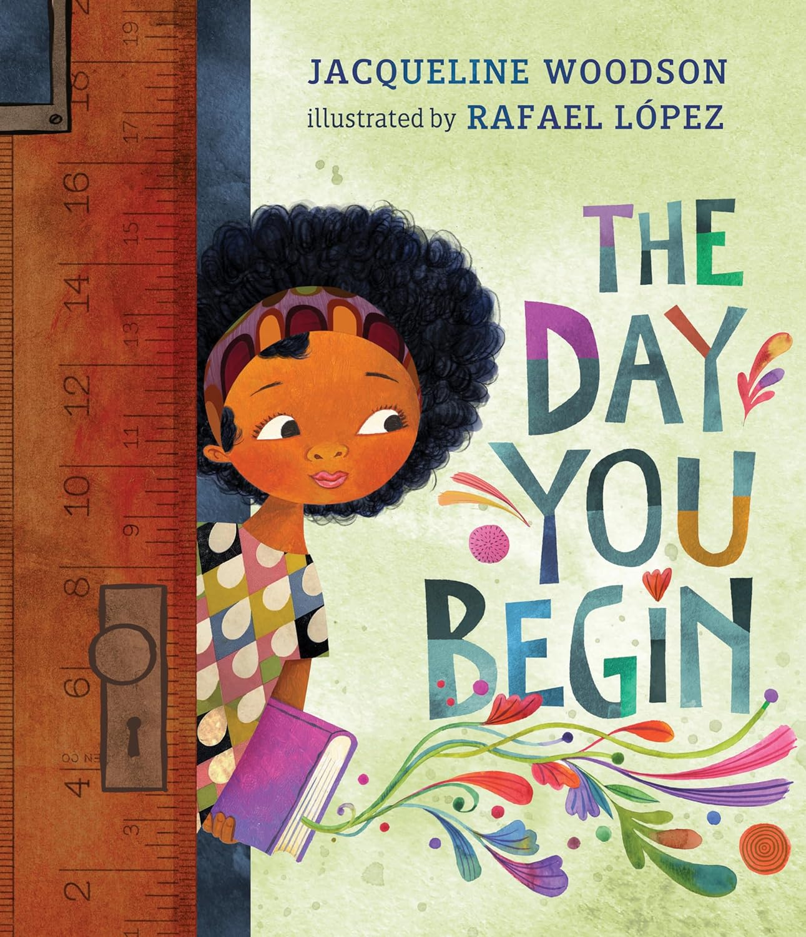 | Text -Sofia Valdez, Future Prez By Andrea Beaty  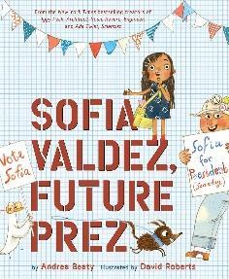 | Text -  Gut Garden  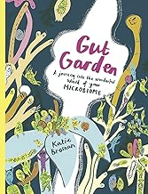
English  Writing and reading |  | Whole class reading  Varjac Paw | Whole class reading  When the Mountains Roared | Whole class reading  The Boy at the Back of the Class (SSELP text) | Whole class reading  Percy Jackson and the lightening thief | Whole class reading – Percy Jackson and the lightening thief | Whole class reading –  There’s a boy in the girls bathroom
 |  | Writing  Poetry – Courage out loud (8Days)  Narrative- Varjac Paw  Adventure story - Write a new part of the story (Holly story)  Non Fiction – Non chronological about an aspect of Roman Britain | Writing -  Narrative – To entertain  When the Mountains Roared-Descriptive writing (setting and character)  Non fiction – Recount describing the move to India (letter) | Writing  Narrative -Retell the first day in class from Ahmet’s POV  Non Fiction  ? | Writing -  Narrative - Journey Aaron Becker  The Secret Map  Discover a secret map inside an old book.  Write about your journey following the map’s clues to find treasure or a secret place.  What obstacles do you face along the way?  Non Fiction  Writing a Persuasive Travel Brochure for a Magical World  Design a travel brochure advertising one of the magical places the girl visits in Journey.  Use persuasive language and facts about what to see and do there. | Writing -  Non Fiction  Create a guide to survive Camp Half-Blood.  Include important rules, what to bring, who the key people are, and what activities they’ll do.  Narrative – Perseus and Medusa  Medusa’s Side of the Story  Imagine the story from Medusa’s perspective. Why is she the way she is? How does she feel about being feared and hunted? Write a short story or poem that explores her feelings.  . | Writing  Poetry – Courage out loud  Non fiction –  Diary entry  Bradley's Journal  Write a diary entry from Bradley’s point of view after his first session with Carla. How does he really feel?  Narrative – Extra chapter  A new student arrives at Red Hill School, and Bradley decides to help them fit in. What kind of mentor is he now?  The new kid reminds him of his old self.
Mathematics |  | Place Value  Addition & Subtraction | Area  Multiplication & Division | Multiplication & Division  Length & Perimeter | Fractions  Decimals | Decimals  Money  Time | Shape  Statistics  Position & Direction
History |  | British History Study  The Roman Empire and its impact on Britain  What impact did the Romans have on Britain? |  | A study of an aspect or theme in British history  Industrial revolution – Kelham island and the Buffer Girls  Why was the industrial revolution a significant turning point in British history and how did it impact Sheffield? |  | International History Study  Ancient Greece – a study of Greek life and achievements and their influence on the western world  How did the Ancient Greeks and their achievements influence the Western world today?
Geography |  |  | How can we be more sustainable?  Focus on Trade and fair trade  Focus on use of sustainable energy. |  | How well do we know our  European neighbours? Focus on a comparison between London and Athens (Greece) |  | Map skills  https://www.rgs.org/schools/resources-for-schools/map-skills
Science |  | States of Matter | Living Things and Their Habitats | Electricity | Sound | Animals, including humans  Digestive system, Teeth, Food chains
RSHE |  | Recap M1  M2) Are we happy all the time? | Os4) Personal Information  Os5) Digital Media  Os6) Verifying content and echo chambers. | C3) How can we help the people around us?  Fr3) Are friendships always fun? | Recap Fa 2  Fa3) How should we treat people who are different? | Recap C2  Recap Fr 1 and 2  C4) How can I be a great citizen? | FIRST AID (2 lessons)  Recap P2  P3) How do I stop getting ill?
RE |  | L2.12 How and why do people try to make the world a better place? Christians, Muslims, non-religious  (5 lessons) | L2.4 What kind of world did Jesus want?  (4 lessons) | L2.2 What is it like for someone to follow God?  (3 lessons reading lessons) | L2.8 What does it mean to be Hindu in Britain today?  (2 lesson and a trip) | L2.6 For Christians, what was the impact of Pentecost?  (visitor and lessons) | L2.11 How and why do people mark the significant events of life? Christians, Hindus, Muslims, non-religious  (1 day)
Art |  | Printing day  Key concepts - colour, pattern | Painting  Concepts – Colour, pattern and texture  Climate change – two sides to the earth  Theoretical Knowledge - Artists  Thomas Moran (water colour artist)  Recap Paul Klee (taught in Y1)  Diversity  Benjavisa Ruangvaree | Art day - Digital media  Photo editing | Drawing  Concepts – Line, pattern and shape  Theoretical Knowledge - Artists  Michelangelo  Leonardo da Vinci  Detailed drawings of Roman Statues / Roman Gods | Sculpture  Concepts – form and space  Theoretical Knowledge - Artists  Variety of Greek  Lysippus  Erwin Meijier  Philippe Faurat  Diversity  Beatrice Hoffman | Collage Art day – transition  Y4 – The Superpower of Looking: a journey across a stormy sea | Art UK  Y4 – Derek Gores
DT |  | Textiles: Fastenings (Lessons 2-4; omit lesson 1)  Electrical systems: Torches (Lessons 2 - 4; omit lesson 1) | Cooking - skills | Mechanical systems: Making a slingshot car  (4 weeks) | Links to fair trade food  Cooking and nutrition: Adapting a recipe (2 lessons in 1 day) | Cooking and nutrition: Adapting a recipe (2 lessons in 1 day) | Structures: Pavilions (4 lessons)
Music |  | Body and tuned percussion (Theme: Rainforests) | Rock and roll | Changes in pitch, tempo and dynamics (Theme: Rivers) | Haiku, music and performance (Theme: Hanami) | Samba and carnival sounds and instruments | Adapting and transposing motifs (Theme: Romans)
Computing |  | The internet | Repetition in shapes | Creating media – photo editing | Data logging |  | Repetition in games
PE | In | Fundamentals | Dance | Gymnastics | Dance | Tennis | Gymnastics
PE | Out | Ball Skills | Basketball | Hockey | Handball | Athletics | Cricket

