Norfolk Community Primary School – History | Topic: Explorers | Main subject: History | Year 2 Autumn 1

Timeline
1492 | 1650-1730 | 1770 | 2004
Christopher Columbus discovered America | The Golden Age of Piracy | Captain Cook discovers and claims Australia and other islands for Great Britain. | Dame Ellen MacArthur becomes the fastest woman to sail around the world alone.
What I should already know

I have learned about historical figures from the past and what they achieved.

I have learned about:
Grace Darling, Neil Armstrong and about old toys and what life was like for my grandparents when they were young.

What I will know by the end of this unit
I will place the explorers I am learning about on a timeline.
I will research how the explorers lived and learn about their lives.
I will find the countries the explorers visited and discovered on a map.
I will investigate some of the changes to how people lived after the explorers made their discoveries.
I will ask questions about the explorers and how they travelled.
I will reflect on the lives of the explorers and how they are celebrated in the UK.

Knowledge
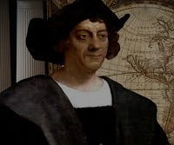 | Christopher Columbus  Christopher Columbus was born in1451 and was an Italian explorer and navigator, who completed four voyages across the Atlantic Ocean. He led the first European expeditions to the Caribbean, Central America, and South America. Columbus was famed for bringing new animals, plants, food and lifestyles from the ‘new’ world that he had found. Columbus died in 1506. There have been many places, roads, schools and and buildings named after him.
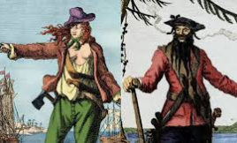 | The Golden Age of Piracy  Thousands of pirates were sailing the seas between 1650 and 1720, and these years are sometimes known as the 'Golden Age’ of piracy. Famous pirates from this period include Henry Morgan, William 'Captain' Kidd, 'Calico' Jack Rackham, Bartholomew Roberts and the fearsome Blackbeard (Edward Teach). This Golden Age came to an end in the 18th century. Many of the most famous pirates had a terrifying reputation, and they advertised this by flying gruesome flags, including the 'Jolly Roger' with its picture of skull and crossbones.
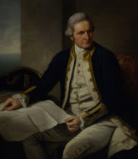 | Captain Cook  Captain James Cook was born on 27 October 1728 in a small village in Yorkshire. At the age of 17, Cook moved to the coast, settling in Whitby and finding work with a coal merchant. In 1755, Cook enlisted in the Royal Navy. In 1769 Cook sailed along the length of Australia's eastern coast, which had never before been seen by Europeans. Cook claimed it for Britain and named it New South Wales. On the 14th of February 1779 Cook was involved in a fight and died.
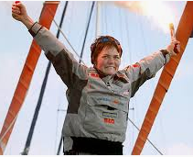 | Dame Ellen MacArthur  Dame Ellen MacArthur was born in 1976 is a retired English sailor, from near Matlock in Derbyshire. She is a successful solo long-distance yachtswoman. On 7 February 2005 she broke the world record for being the fastest woman to sail solo around the world, a feat which gained MacArthur international fame. MacArthur now teaches young people how to sail and works to support charities for young people.

Key Vocabulary
explorer | A person who explores a new or unfamiliar area.
Famous | Someone or something that is known about by many people.
Voyage | A long journey involving travel by sea or in space.
discovery | The action or process of discovering or being discovered.
Ocean | A very large expanse of sea.
Continent | Any of the world's main continuous expanses of land (Europe, Asia, Africa, North and South America, Australia, Antarctica).
Navigator | A person who navigates a ship, aircraft, etc. This person uses maps to find out where to go.
maps | A picture or diagram of an area of land or sea showing physical features, cities, roads, etc.
Pirate | A person who sails in a ship and attacks other ships in order to steal from them.
Sailor | A person whose job it is to work as a member of the crew of a naval ship or boat.
travel | To go or be moved from place to place.

Useful links
https://www.ducksters.com/biography/explorers/ captain_james_cook.php
http://www.bbc.co.uk/history/historic_figures/cook _captain_james.shtml
https://www.rmg.co.uk/discover/explore/golden-age-piracy
https://www.bbc.co.uk/bitesize/articles/znchkmn
https://www.ellenmacarthur.com/



