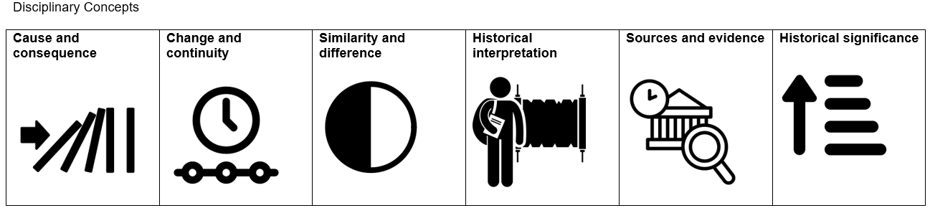
Norfolk Community Primary School – Theme questions

Subject | Autumn 1  Tuesday 1 September 2026 until Friday 23 October 2026  (8 weeks) |  | Spring 1  Monday 4th January 2027 until Friday 12th February 2027  (6 weeks) |  | Summer 1  Monday 12th April 2027 until Friday 28th May 2027  (7 weeks)
Subject | Peace and Freedom |  | Equity and Social Justice |  | Participation and citizenship
FS1
FS2 | How have I changed since I was a baby?  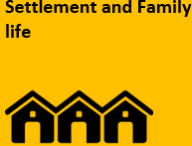 |  | 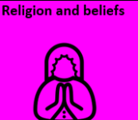  What are our favourite celebrations each year? |  | Why do we wear different clothes during the year?
Y1 | Changes within Living Memory  Family Life: houses and toys    How has family life changed since the 1950’s? |  | Significant Individuals  Martin Luther King  Floella Benjamin  How were these people significant?  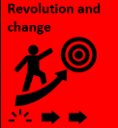  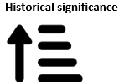 |  | Changes within Living Memory  How have seaside resorts changed in the last 50 years?  Significant Individuals  Who was Grace Darling and what did she do to help others?  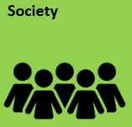
Y2 | Significant historical events, people and places in their own locality.  Victorian children - schools, factories  What was life like for children in Victorian times? |  | Significant Individuals  In what ways were Florence Nightingale and  Edith Cavel similar and how are they significant?   |  | Events Beyond Living Memory  The Great Fire of London
Y3 | British History Study  Changes in Britain from the Stone Age to the Iron Age  How did life change between the stone age and the iron age and how do we know?  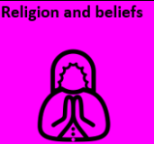 |  | Significant Individuals  How have women’s rights changed since the 18th century?  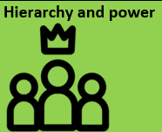  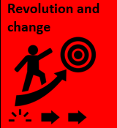 |  | International History Study  The achievements of the earliest civilizations – an overview of where and when the first civilizations appeared and a depth study of Ancient Egypt  How did the civilisation of Egypt wax and wane?
Y4 | British History Study  The Roman Empire and its impact on Britain  What impact did the Romans have on Britain?  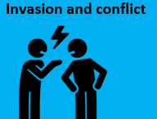 |  | A study of an aspect of history or a site dating from a period beyond 1066 that is significant in the locality  Industrial revolution – Kelham island and the Buffer Girls  Why was the industrial revolution a significant turning point in British history and how did it impact Sheffield? |  | International History Study  Ancient Greece – a study of Greek life and achievements and their influence on the western world  How did the Ancient Greeks and their achievements influence the Western world today?  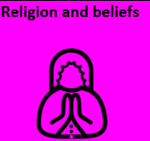
Y5 | British History Study  The Viking and Anglo-Saxon struggle for the Kingdom of England  What were the effects of Anglo-Saxon, Viking and Scots settlement in Britain?  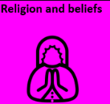  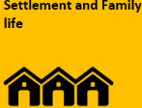  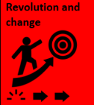  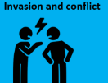 |  | Significant Individuals  Katherine Johnson  The Space race - significant individuals  Who are the significant individuals in the history of space exploration and what impact did they have? |  | International History Study  A non-European society that provides contrasts with British history – Mayan civilization c. AD 900.  Why should we study the Maya?
Y6 | A study of an aspect or theme in British history that extends pupils’ chronological knowledge beyond 1066  Journeys: the story of migration to Britain  Why did migrants come to Britain and how have they changed Britain? 2024/25 (move autumn 1 2025/26) |  | A study of an aspect or theme in British history that extends pupils’ chronological knowledge beyond 1066  How did the experience of British people differ to other places in Europe during World war 2?

